**Introduction to Data Structure:**

* When we have huge amount of data then basically we take the help of data structure to organize the data into mamory.
* So it is the way of organizing the data.
* Why we organize data: So that after organizing data it becomes easy to process.
* We will learn different type of data structrue as listed below

|  |  |
| --- | --- |
| 1. Singly Linked List | 7- Binary Tree |
| 1. Doubly Linked List | 8- Binary Heaps |
| 1. Circular Singly Linked List | 9- Graphs |
| 1. Arrays | 10 Matrix |
| 1. Stacks | 11 Tries |
| 1. Queues |  |

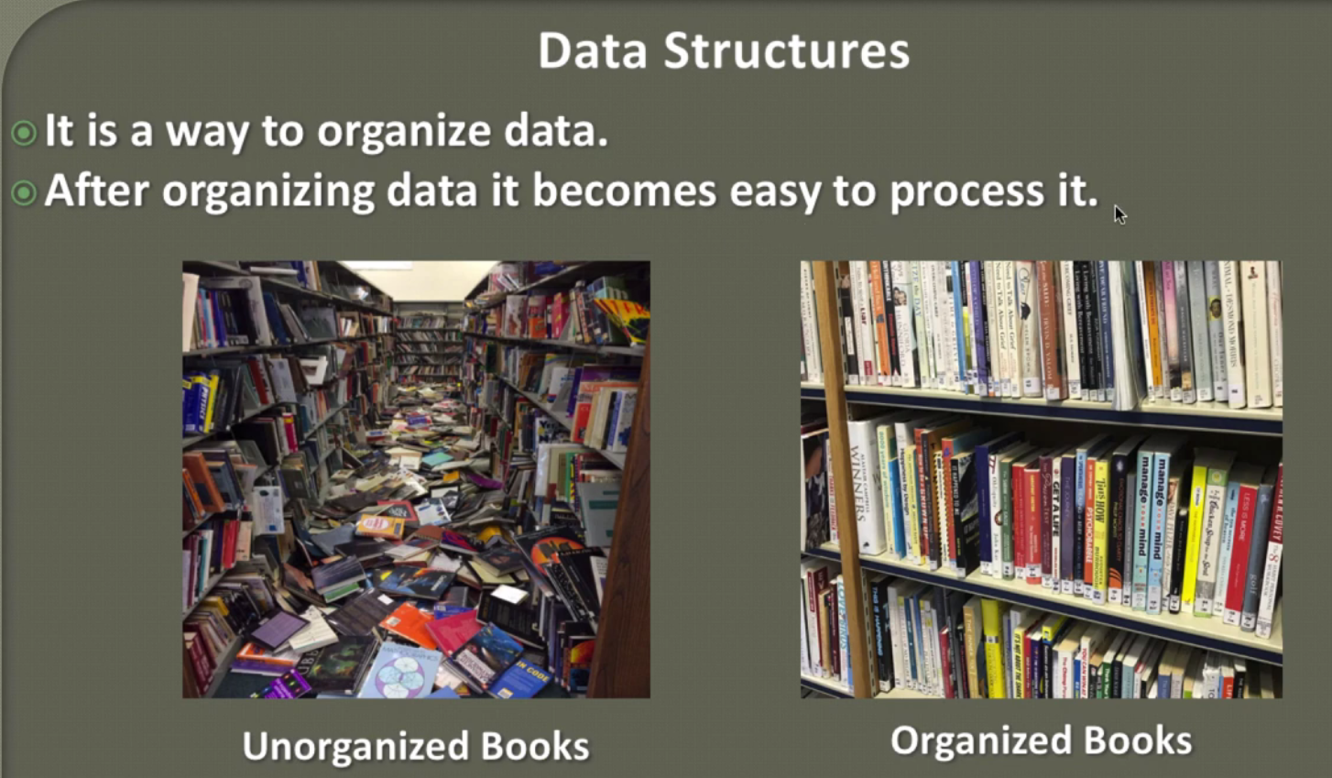

**Introduction to Algorithm Analysis**

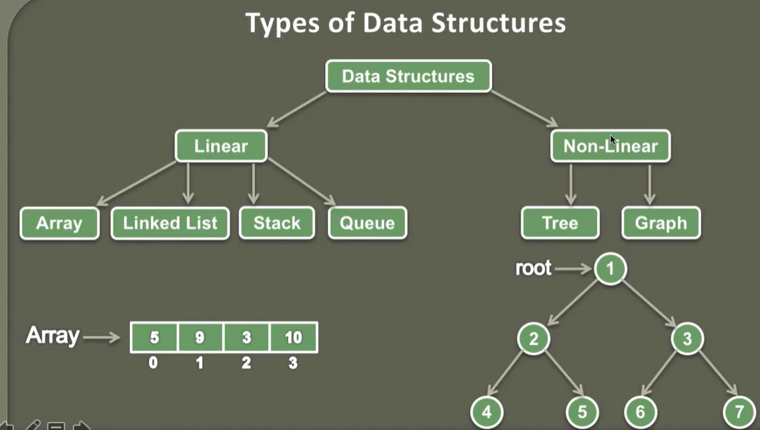

Linear:

* Arranged into a sequential manner and attached to each other so that traversing becomes easier.
* Usually travers is a single level
* Example given above

Non-Linear:

* They are not arranged in sequential and they are connecte to each other from different path
* They are stored into multi level and that is why travers is also multi level and which not easy as compare to liniear
* Example given above

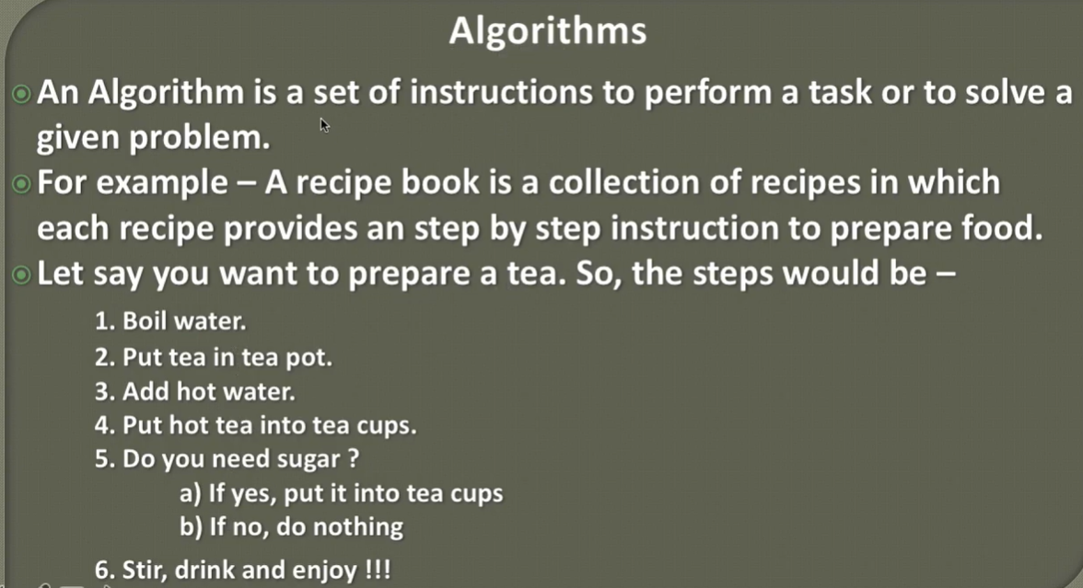

So here in the above example the step to prepare the tea is nothing but the set of instruction which help us in making tea. Similarly in data structure algorithem help us the solving the given problem.

Example of print the avarage of 3 given number:

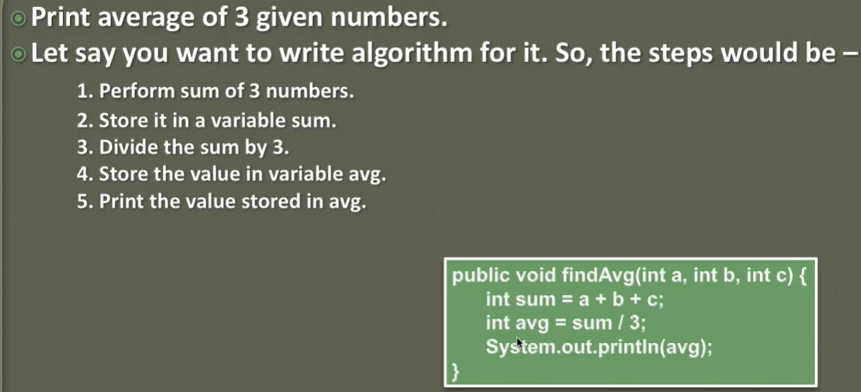

**Analysis of Algorithm**

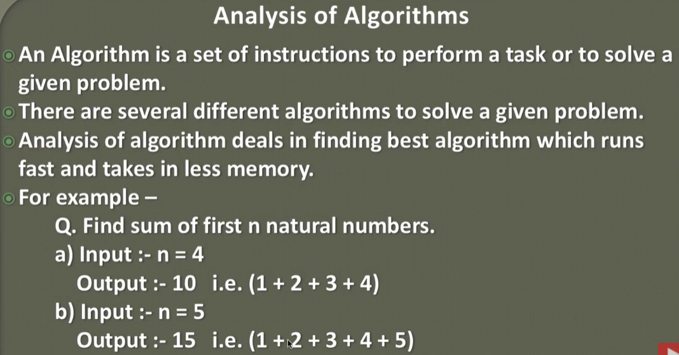

When we talk about analysis of algo then the set of instruction becomes very important because in-order to salve a given problem we have several different algo and out of these several different algo we try to find best algo which runs fast and takes less memory.

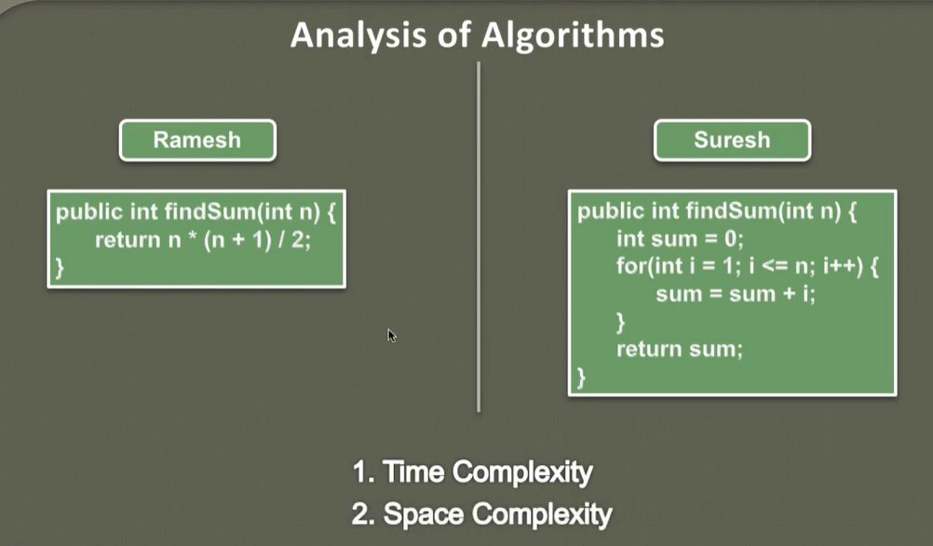

Here Ramesh and Suresh come with their algo.

|  |  |
| --- | --- |
| Ramesh comes up with a formula to sum of natural number | In Suresh program:   1. He is creating one variable sum and initializes it with zero. 2. Providing a for loop which start from to n 3. Adding sum inside the for loop |

But as of now there is no way to determine which one is best algo and program to find the sum of n natural numbers.

So in-order to determine the best algorithm among these two, we usually checks two things.

1. Time Complexity : How much time this algorithm is taking to complete
2. Space complexity: How much memory this algorithm is taking to complete.

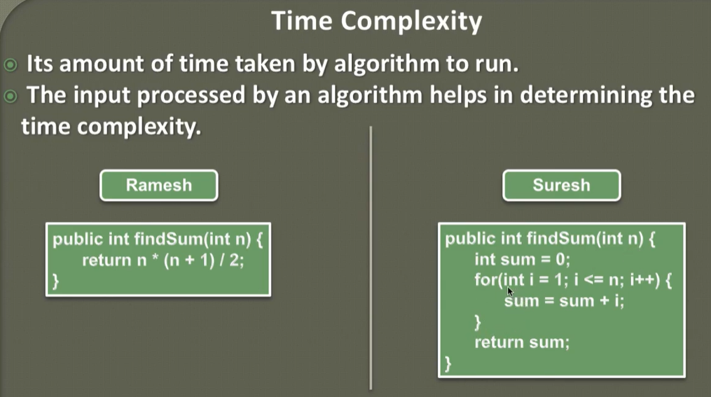

As here in case of Ramesh he is using formula where he just putting the number (n) calculating and return it back. While in case of Suresh he takes several steps to calculate same number so the time take by Suresh algo will be more than Ramesh algo.

|  |  |
| --- | --- |
|  |  |

So Ramesh algo takes very less time to complete and that is why Ramesh algo is best in terms of performance.

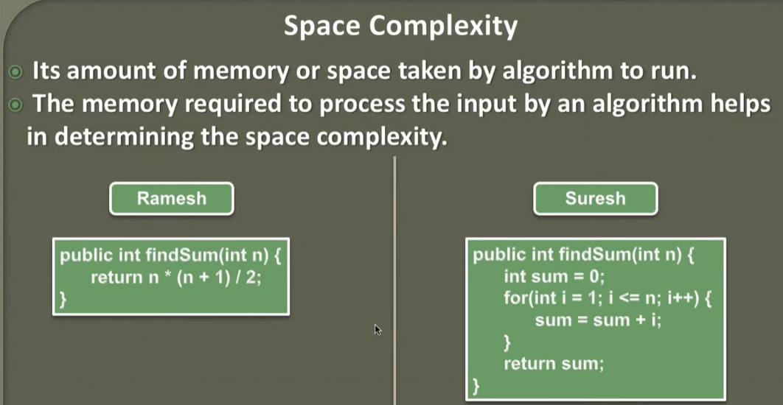

Note: Basically we cannot determine the time complexity and space complexity by looking, there we have several mathematical tools to identify (usually terms them asymptotic analysis of algo)

# Asymptotic Analysis of an Algorithm

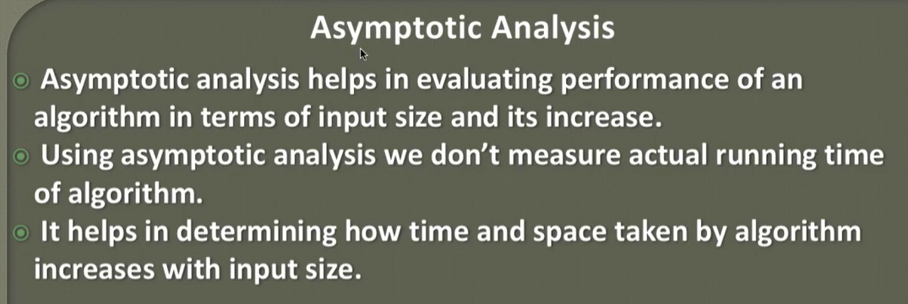

In the previous sections we saw that how the time and space complexity can affect our algorithm. But usually we don’t go by exact number like how much time and space is taking and algorithm to complete. We use some mathematical model which helps us in determining time and space complexity of an algo and these models is called as asymptotic analysis. Asymptotic analysis is being done by using asymptotic notations. So basically in AA we keeps varying the input size and analyze the time and space taken by an algo to complete.

**Asymptotic Notations | Omega, Theta and Big O Notations**



So AN does not provide the exact estimation of time and space to complete, AN just gives us a rough estimation that, how much an algo taking time and space to complete its execution. So as mention above AN just help us in determining [Best, Average & Worst] case of an algorithm to complete its execution. For example we cannot predict the exact average of a car because its depends on the road, traffic and location condition.

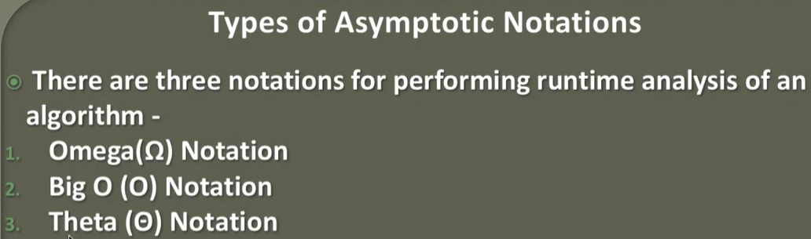

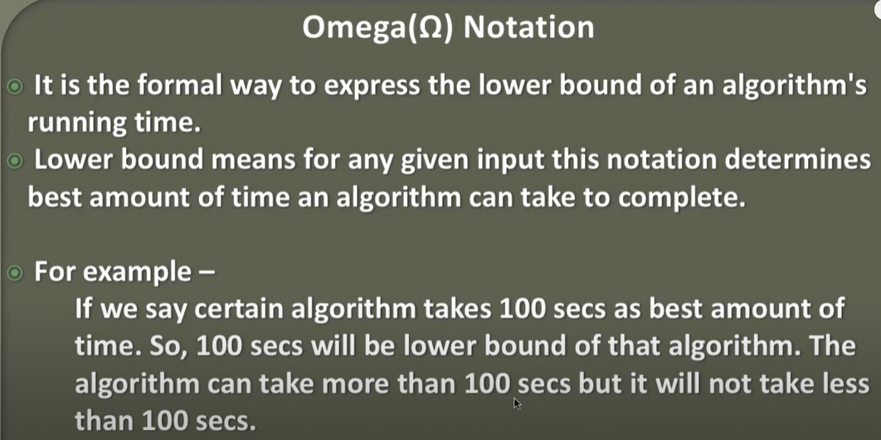

I.e. an algorithm is taking 100 second to complete and can take more time but will not take less than 100 second to complete its execution. This notation is very least use because we are not interested in finding the best amount of time because if this is the best then there will not be any chance to improve it further.

But notation can tell us that what are the minimum resources is required to give the best performance of an algorithm.

Note: Lower bound==🡺 Best or max:

For example a car is giving 30 Km mileage in one liter and this is the maximum performance and now performance cannot be increased at all

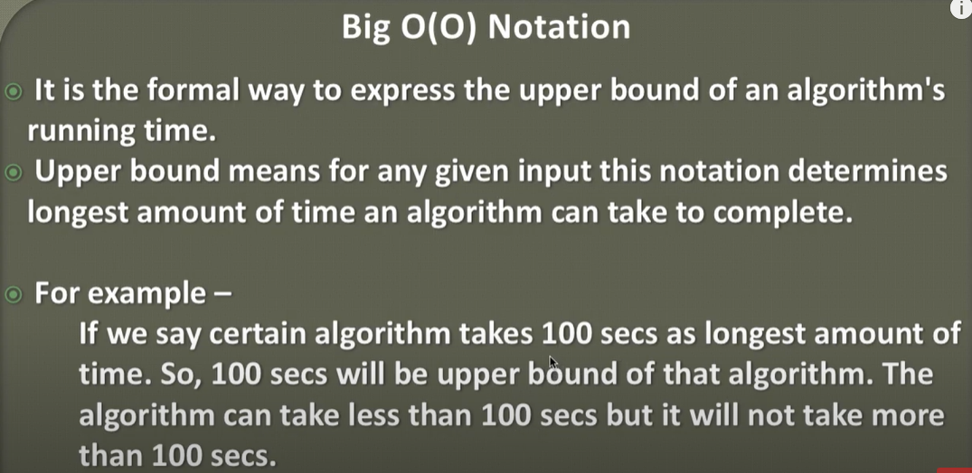

Basically this notation use mostly just to know that what is max or longest amount of time an algorithm is taking, because this provide the worst time analysis for any algorithms and after getting this we can start working on algo optimization.

For car is giving maximum 20 Km worst mileage and still there is a chance to increase its performance or mileage.

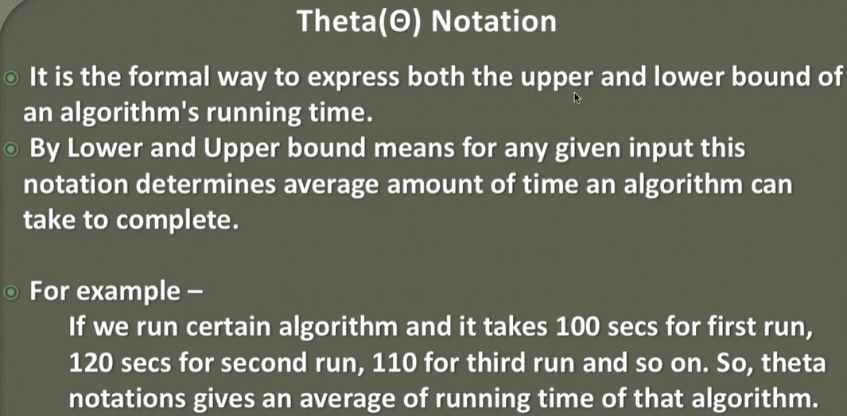

This notation is also use very less because most of the people are interested to how much time is talking to complete not about average or less time. So Big(O) notation is used mostly in case of algo analysis.

# Analysis and Rules to calculate Big O notation

As we know that the Big(o) notation provide an upper bound of a running algo i.e. the longest amount of time an algo is taking to complete its execution. So here we have some rules to compute running time of algo using Big (O).

Let’s say we have a single processor machine and this processor running the algo sequentially then the rule applied on this algo is listed below.

Note: Here 1- unit of time could be any of these🡺 1 second, 1 mili second, 1 nano second.

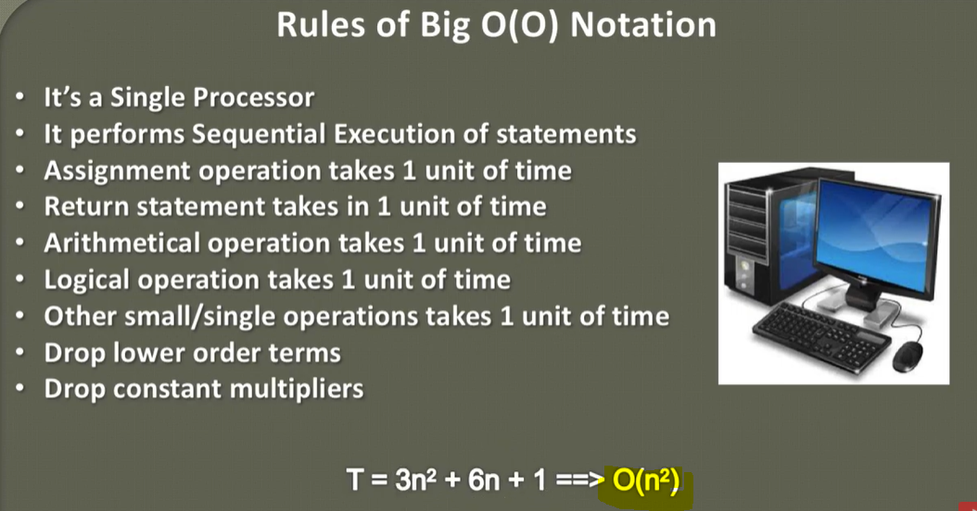

|  |  |
| --- | --- |
| Int x =5; | 1 unit of time |
| return x; | 1 unit of time |
| (X+Y) (arithmetic operation) | 1 unit of time |
| Logical operation (X && Y) (x==y) (X|Y) (!X) (!Y) | 1 unit of time |
| Small single operation time | 1 unit of time |
| Drop Lower order terms= T= n²+3n+1 | So here n² will be consider as max and will drop the lower terms 3n+1  And thus complexity will be denoted as T= n²+3n+1 🡺 O(n²)  So here the time complexity will be O(n²) |
| Drop constant multipliers T= 3n²+6n+1 | So here will drop the entire constant like (number) from (3n²) we will drop 3 as per the above rule will drop lower term (6n+1). Hence the time complexity will again be: T= 3n²+6n+1 🡺 O(n²) |

# Calculating Time complexity of Constant Algorithm (Big O)

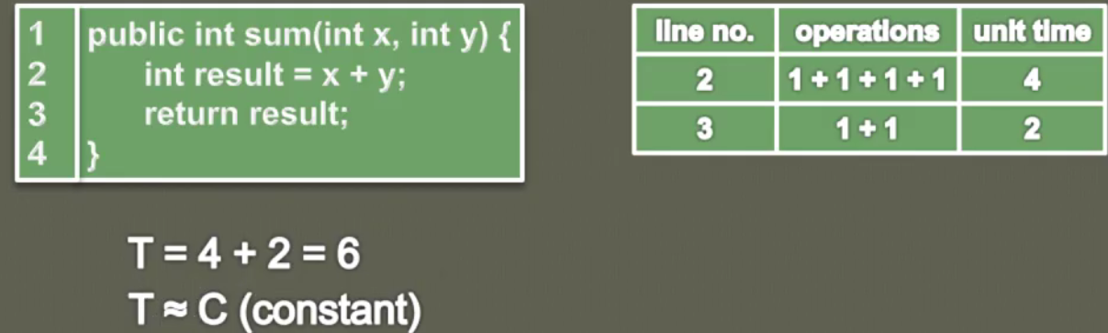

Here in the above program for line number 2 and 3 we are calculating time complexcity

|  |  |
| --- | --- |
| Accessing x | 1 unit |
| Accessing y | 1 unit |
| Arithmatic operation (x+y) | 1 unit |
| Assigning (x+y) to result | 1 unit |
| return result; | 1 unit for accessing result + 1 unit for retrun |

So total time complexcity of above program = T= 4+2 = 6 and here 6 is constant so it will represented as : T= C(Constant)

Example 2

|  |  |
| --- | --- |
|  | Here we have one int[] arr and int 1  And in the retrun we are acessing element by passing i.  So let’s say if we have 100000 elment or 10 element it will take the same amout of time as per the element size so in general we will say it is taking constant amount of time and Big(O) for constant will be denoted as:  Time Complexity = O(1) |

In complete sence : Time Complexity for constant will be given as:

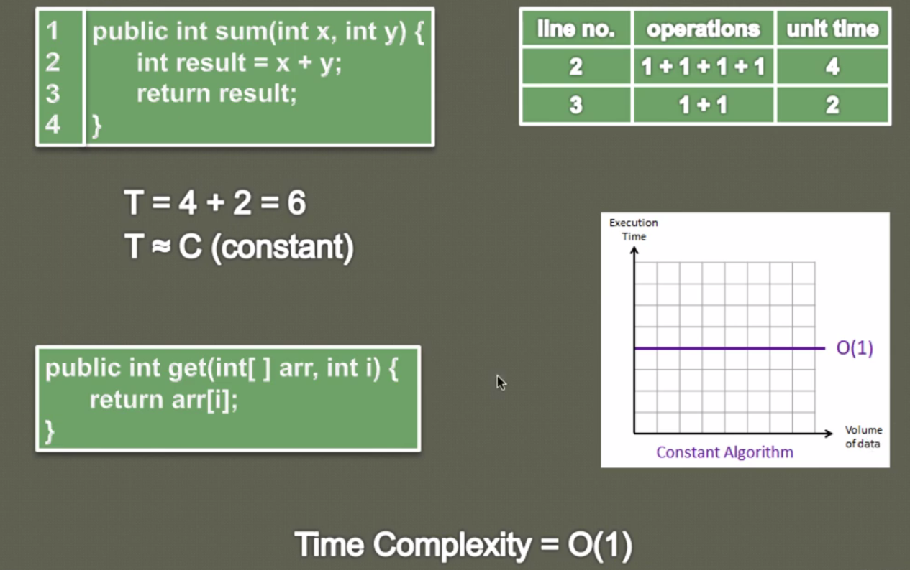

Time is directly proportional to constatn:

**Time complexicity for linear algo**

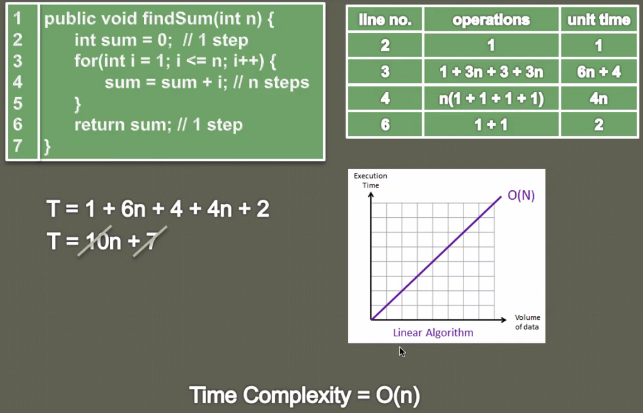

Let’s take n= 3

|  |  |  |  |
| --- | --- | --- | --- |
| Line-2 | Int sum =0; [Assignment] | 1 operation | 1 unit |
| 2 | for(int i=1; i<=n; i++)Here in the for loop we have 3 statement | [Assignment (int i=1)]Compare (<=)This compare statement will execute (3+1) i.e. 3 times for true condition and 1 for false so this statement will execute (n+1)Accessing i++Here first accessing i + increment i + assign back to i = 3 operation-so for one iteration of for loop it will execute 3 times and for n loop it will be n times | 1 unit+3(n+1)+3n |
|  |  |
| 3 | Sum= sum + i | Accessing sum + accessing i + (adding sum +i) + then assigning to sum 🡺 so total 4 operation is happening. For for n loop this line will execute n times 4(1+1+1+1) | 4n |
| 4 | return sum; | Assessing sum + then return | 1 unit + 1 unit |

Total time complexity (T) = 1 + [1+3(n+1) +3n] + 4n + 2 =🡺 10n+7

So as per the above run we will ignore lower order terms and constant so we will ignore constant 7 and 10.

So finally the T= O (n) 🡺 [Time is directly proportional to value n which is nothing but input size]

**Calculating Time complexity of a Polynomial Algorithm (Big O)**

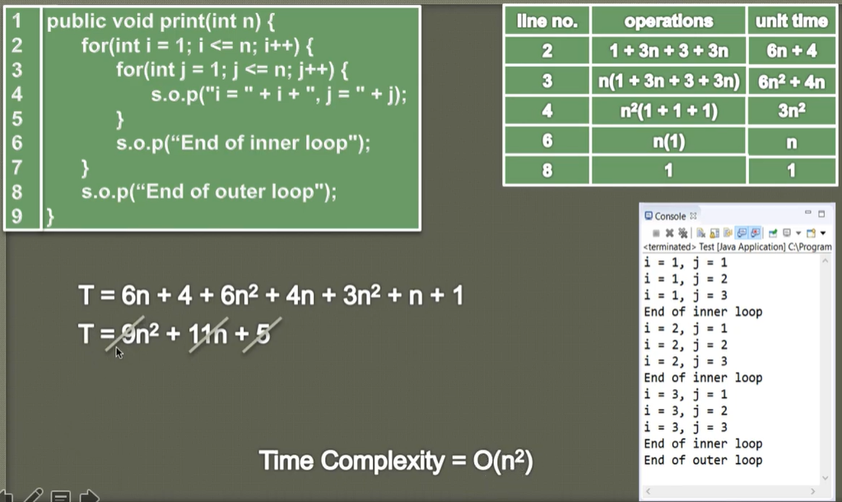 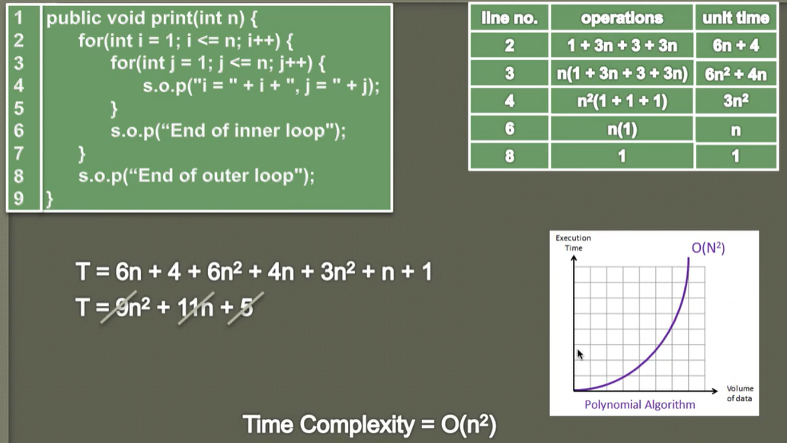

Time is directly proportional to n² where n is the size of input:

Note: Time Complexity having one for loop = O(n): Having two for loop O(n²) : Having three for loop O(n²) and so on…

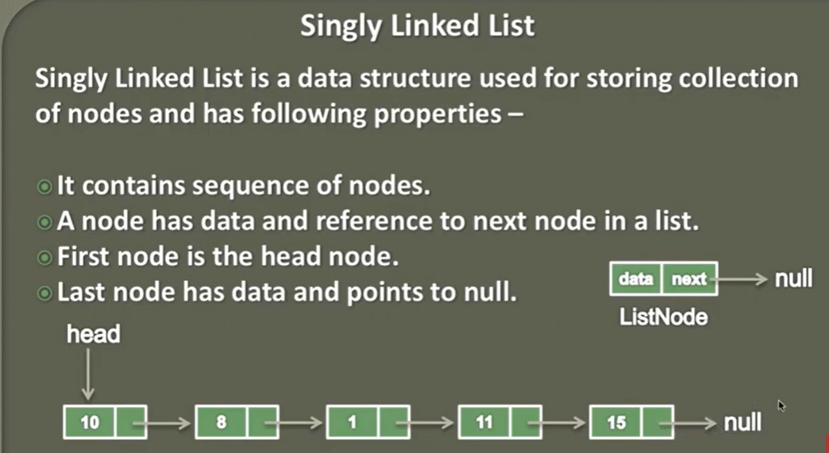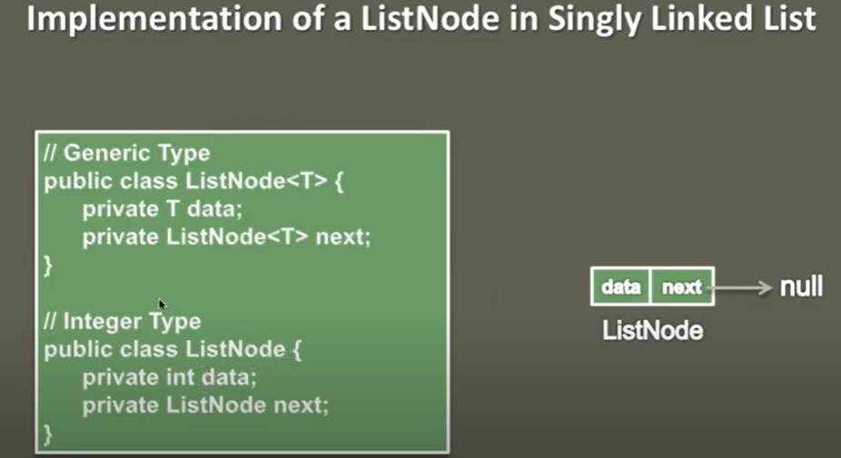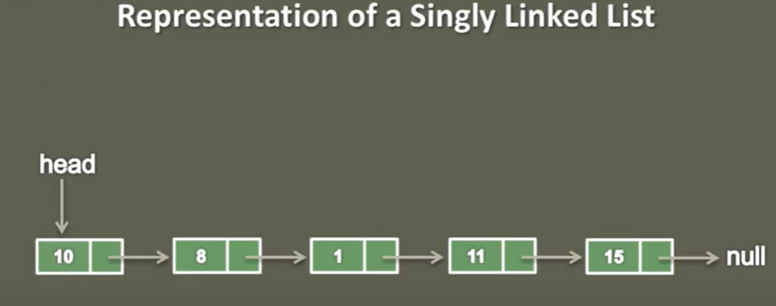

So here first we have first node called head node having data 10 and it is pointing to next node having data 8 and this chain goes till last node pointing to null. Head node is the most important node because it holds the complete list of node.

**Representation of SinglyLinked list**

|  |
| --- |
| 1- Create a class with name SinglyLinkedList [public class SinglyLinkedList {}]  2- Inside the SinglyLinkedList class, Create static class with name ListNode having two property 1- int data 2- Reference Variable(next)of ListNode type pointing to next node  3- Now create are reference variable (head) of ListNode type inside the SinglyLinkedList. This head will be the first node and will hold other ListNode.   1. Create a constructor of ListNode (int data) to create or hold the data in the newly created ListNode and since it will be new independent node so by default its next will be pointing to null.   private static class LinkNode { // Point number 2  private int data; // Point number 3  private LinkNode next; // Point number 2  public LinkNode(int data) { // Point number 4  this.data = data;  this.next = null;  }  }  **So the complete code of represent singly linked list is given below**  public class SinglyLinkedList {  private LinkNode head;  private static class LinkNode {  private int data;  private LinkNode next;  public LinkNode(int data) {  this.data = data;  this.next = null;  }  }  } |

**Creating a SinglyLinkedList:**

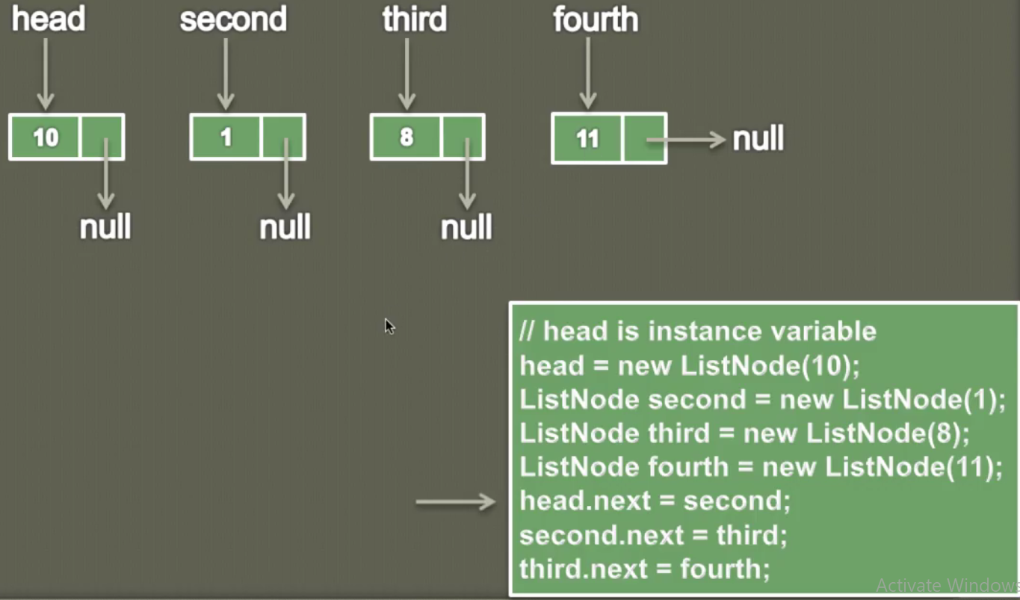

As we know that the first node of the SLL is called head which holds others nodes. So

1. Create first node as head using ListNode constructor having data 10 and next point to null
2. Similarly create second, third, fourth node having data 1, 8, 11 and next of each node points to null. So now including head we have four independent nodes. Now to make it into list we have to point each node “next” to other node.
3. head.next = second [Now “next” of head which was pointing to null now start pointing to second node or we can say that the value of second node now assigned to head’s next]
4. second.next = third; [Now “next” of second node which was pointing to null now start pointing to third node]
5. third.next = fourth; [Now “next” of third node which was pointing to null now start pointing to fourth node]
6. Since we have only four node only so the “next” of fourth node will point to null only and this means this is the last node of the SLL.

|  |
| --- |
| **public** **class** SinglyLinkedListCreationAndLinking_2 {  **private** ListNode head;  **public** **static** **class** ListNode{  **private** **int** data;  **private** ListNode next;    **public** ListNode(**int** data) {  **this**.data=data;  **this**.next=**null**;  }  }  **public** **static** **void** main(String[] args) {    SinglyLinkedListCreationAndLinking_2 sll = **new** SinglyLinkedListCreationAndLinking_2();  // Created independent node of SLL having data and their next pointing to null according to constructor.  sll.head = **new** ListNode(10);  ListNode second = **new** ListNode(1);  ListNode third = **new** ListNode(8);  ListNode fourth = **new** ListNode(11);    // Start linking to each other to form a chain.  sll.head.next= second; // 10 🡺1  second.next=third; // 10 🡺1 🡺8  third.next=fourth; // 10 🡺1 🡺8 🡺11🡺null  }  } |

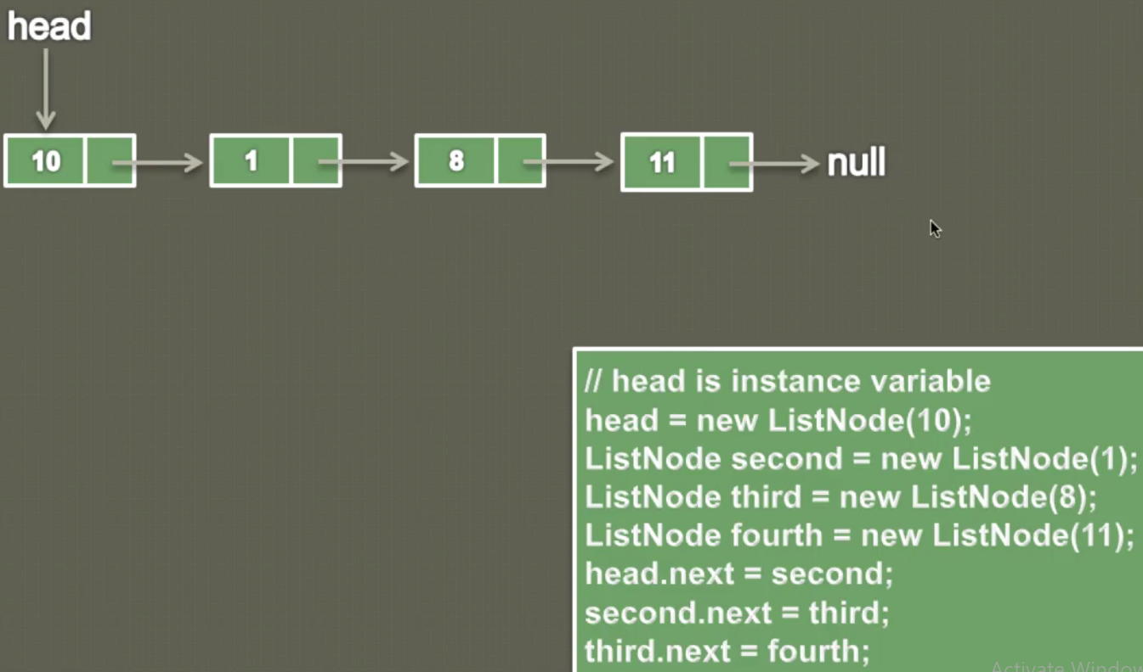

So now we have got complete list where first node is head and this head node holding complete list and last node is pointing to null.

**Printing Singly Linked List:**

As per the image we have four node list and we have to print each node by traversing each node one by one.

|  |
| --- |
|  |
| Step1- Create a temprary ListNode “current” and assign the head node (first node of SLL) value to this current node. |
| **Step2-** Now in the while loop we keep traversing until current encounter null  **Step3-** Inside the while loop we will keep printing each current node value and keep assigning next node of current to current node |
|  |
|  |
|  |

**So now finally the current node start poinint to null and it will come out from the while loop and will print null finally.**

|  |
| --- |
| **package** com.core.single.linked.list;  **public** **class** C_PrintSinglyLinkedList_3 {  **private** ListNode head;  **public** **static** **class** ListNode{  **private** **int** data;  **private** ListNode next;    **public** ListNode(**int** data) {  **this**.data=data;  **this**.next=**null**;  }  }  **public** **static** **void** main(String[] args) {  C_PrintSinglyLinkedList_3 sll = **new** C_PrintSinglyLinkedList_3();  **// Creating independent SLL node**  sll.head = **new** ListNode(10);  ListNode second = **new** ListNode(1);  ListNode third = **new** ListNode(8);  ListNode fourth= **new** ListNode(11);    **// Linking all the node to each other to form a chain**  sll.head.next= second; // 10=>1  second.next=third; // 10=>1=>8  third.next=fourth; // 10=>1=>8=>11=>null    sll.printSlinglyLinkedList();  }  **// Method to print Single linked list**  **public** **void** printSlinglyLinkedList() {  ListNode current = head;  **while**(current!=**null**) {  System.***out***.print(current.data+"=>");  current = current.next;  }  System.***out***.print("null");  }  }  Output:  10=>1=>8=>11=>null |

**20-Find length of a Singly Linked List**

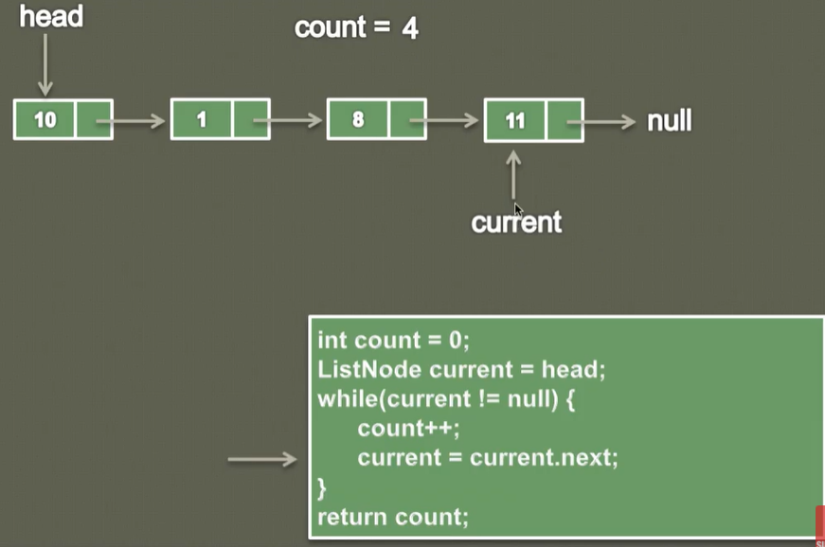

|  |
| --- |
| **public** **class** D_FindLengthSinglyLinkedList {  **private** ListNode head;  **public** **static** **class** ListNode{  **private** **int** data;  **private** ListNode next;  // Created constructor  **public** ListNode(**int** data) {  **this**.data=data;  **this**.next=**null**;  }  }  **public** **static** **void** main(String[] args) {  D_FindLengthSinglyLinkedList sll = **new** D_FindLengthSinglyLinkedList();    // Creating single independent node  sll.head = **new** ListNode(10);  ListNode second = **new** ListNode(1);  ListNode third = **new** ListNode(8);  ListNode fourth = **new** ListNode(11);    // Linking each node to each other to form a chain  sll.head.next= second;  second.next=third;  third.next= fourth;    **int** length = sll.length();  System.***out***.println("The length of single linked list:- "+length);  }  // Method to find length of singly linked list:  **public** **int** length() {  **if**(head==**null**) {  **return** 0;  }  **int** count=0;  ListNode current = head;  **while**(current != **null**) {  count++;  current=current.next;  }  **return** count;  }  }  Output: The length of single linked list:- 4 |

**Note:** Calculating length logic is very similar to printing singly linked list: Travers all the node until encounter null and keep increasing count variable.

**21- Insert node at the beginning of a Singly Linked List in Java (Animation)**

Algo: 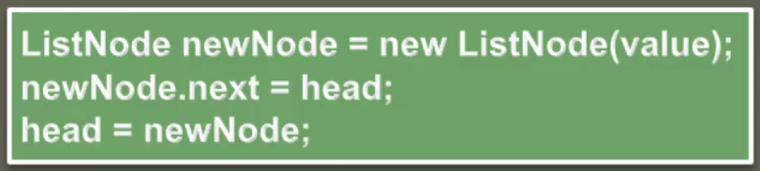

Let’s say initially singly list is empty, then in this case the first node will be head and it will point to null.

|  |  |  |  |
| --- | --- | --- | --- |
|  |  |  |  |

1. Create an independent new ListNode using constructor and passing the value let’s say we have passed data=11
2. Now head and newNode both will point to null because initially new node is not linked to any other node
3. Since first node always will be head node so we will make this new node the head of the SLL and for that assign the head to newNode.next [or point newNode.next to head]
4. Finally assign the newNode value to head

Now our SLL has one node (head node). Now let’s we want to add one more node have value =8

|  |  |  |
| --- | --- | --- |
|  |  |  |

1. Create an independent new ListNode using constructor and passing the value let’s say we have passed data=8
2. Now head and newNode both will point to null because initially new node is not linked to head node
3. Since the new node has to be inserted as first node so, let’s point this newNode.next to head
4. Finally make the new node, the head node of the SLL and so assign the newNode value to head



Let’s add third Node having value =1

|  |
| --- |
|  |
|  |
|  |

**Program:**

|  |
| --- |
| **public** **class** E_InsertNodeAtBeginingSLL_5 {  **private** ListNode head;  **public** **static** **class** ListNode{  **private** **int** data;  **private** ListNode next;    **public** ListNode(**int** data) {  **this**.data=data;  **this**.next=**null**;  }  }  **public** **static** **void** main( String[] args) {  E_InsertNodeAtBeginingSLL_5 sll = **new** E_InsertNodeAtBeginingSLL_5();    sll.insetFirst(10);  sll.insetFirst(1);  sll.insetFirst(8);  sll.insetFirst(11);  sll.display();  }  **public** **void** insetFirst(**int** data) {  ListNode newNode = **new** ListNode(data);  newNode.next=head;  head=newNode;  System.***out***.println("Node Inserted:: "+head.data);  }  **public** **void** display() {  **int** count=0;  ListNode current = head;  **while**(current != **null**) {  System.***out***.print(current.data+"==>");  current =current.next;  count++;  }  System.***out***.print("null");  System.***out***.println();  System.***out***.println("Total number of node in the list: "+count);  }  } |
| **Output:**  Node Inserted:: 10  Node Inserted:: 1  Node Inserted:: 8  Node Inserted:: 11  11==>8==>1==>10==>null  Total number of node in the list: 4 |

**Insert node at the end of a Singly Linked List**

|  |  |  |  |
| --- | --- | --- | --- |
|  |  |  |  |

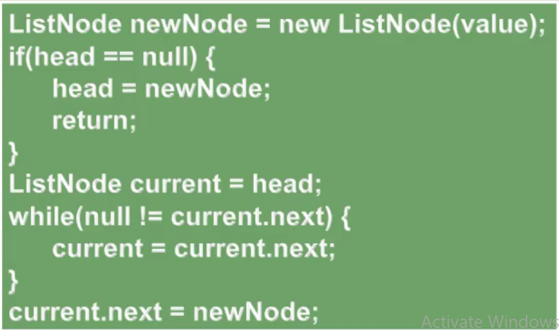

1. Let’s say we have created on independent node using ListNode having value 11 who is currently pointing to null
2. Now will insert this node into SLL at the end, so first we will check that if head == null or not
3. If head is null then please assign this newNode to head because the first node will be head node of the SLL and thus we have inserted on node in SLL at the end.
4. Now let’s create one temporary node “current” and assign the head to this current node so that using this temporary node we can traverse and until we find the current equal to null.
5. In the while loop we will check the condition while (current.next !=null)
6. Inside the while loop assign the next node to this current node so that we can traverse ahead.
7. Now when this current node will equal to null then condition will come out to be false and since now [current.next] is pointing to null so we will assign the newNode to this current node.
8. Now this newNode will start pointing to null and thus it would be considered as last node of the SLL.

Now again lets create one new independent node have value =8 which currently pointing to null.

1. Since now head is having one value so now head is not equal null so the if(head==null) will come out to be false.

|  |  |
| --- | --- |
| 1. Now create one temp node current and assign the head so now the current will start pointing to head. |  |
| 1. As of now we have only two independent node current node and newNode so in the inside the while loop current.next is pointing to null and will not go inside the while loop. Now outside of the while loop we will assigns the current.next to newNode so that this current which was actually pointing to head now will start pointing to newNode |  |

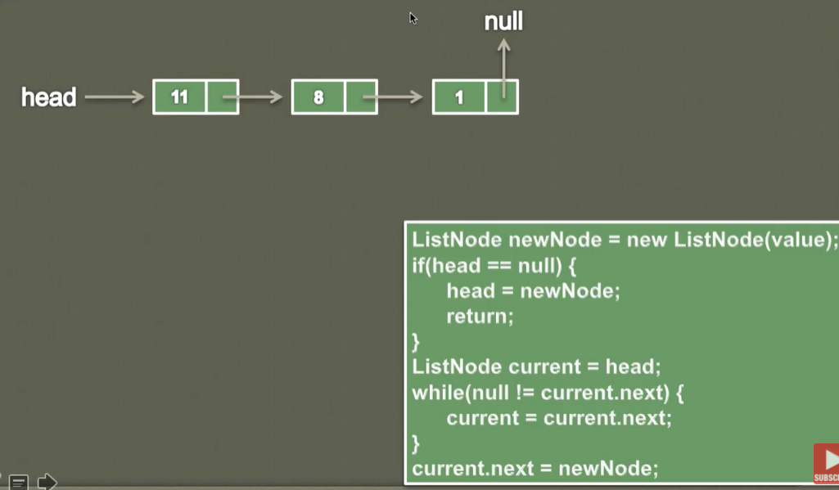

Similarly for next node having value =1. We will traverse until the current start pointing to null and once current points to null then assign the newNode to current and after that newNode will start pointing to null.

Program:

|  |
| --- |
| **public** **class** F_InsertNodeAtLast_6{  **private** ListNode head;  **public** **static** **class** ListNode{    **private** **int** data;  **private** ListNode next;    **public** ListNode(**int** data) {  **this**.data=data;  **this**.next=**null**;  }  }  **public** **static** **void** main( String[] args) {    F_InsertNodeAtLast_6 sll = **new** F_InsertNodeAtLast_6();    sll.instertLast(10);  sll.instertLast(8);  sll.instertLast(12);  sll.instertLast(1);  sll.instertLast(11);  sll.display();  }  **public** **void** instertLast(**int** value) {  ListNode newNode = **new** ListNode(value);  **if**(head==**null**) {  head=newNode;  **return**;  }  System.***out***.println("HeadData:"+head.data);  **int** count =2;  ListNode current = head;  **while**(**null**!=current.next) {  current=current.next;  System.***out***.println("Node:"+count +":"+current.data);  count++;  }  current.next=newNode;  System.***out***.println("Inserted last Node: "+current.next.data);  }  **public** **void** display() {  **int** count=0;  ListNode current = head;  **while**(current!=**null**) {  System.***out***.print(current.data+"==>");  current= current.next;  count++;  }  System.***out***.print("null");  System.***out***.println();  System.***out***.println("Length of Node="+count);  }  } |
| **Output:**  HeadData:10  Inserted last Node: 8  HeadData:10  Node:2:8  Inserted last Node: 12  HeadData:10  Node:2:8  Node:3:12  Inserted last Node: 1  HeadData:10  Node:2:8  Node:3:12  Node:4:1  Inserted last Node: 11  10==>8==>12==>1==>11==>null  Length of Node=5 |

**26-Insert a node in a Singly Linked List at a given position**

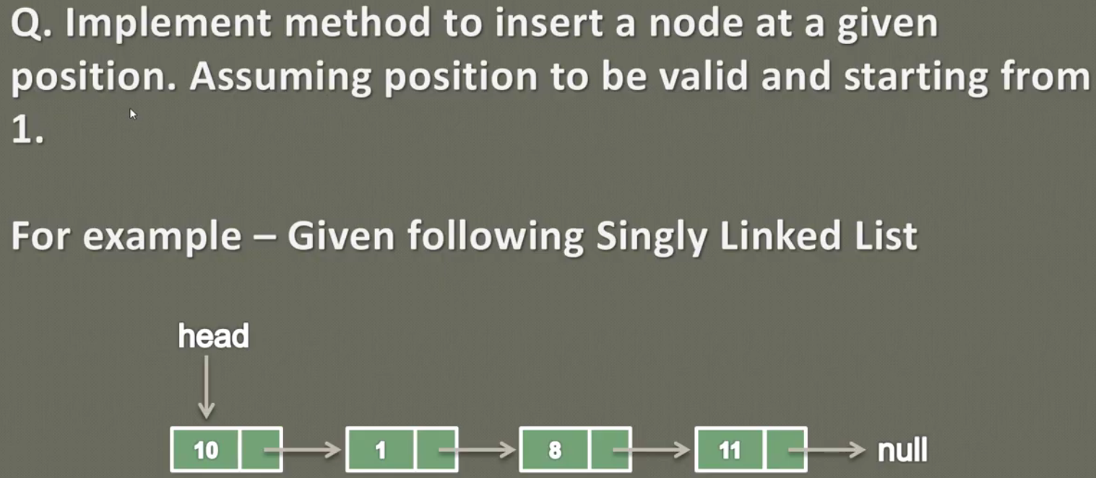

Here position starting from 1 means > starting from head node.

|  |  |
| --- | --- |
| Let’s say we have one SLL with two nodes.  Let’s say we want to insert value 8 at position =1 |  |

1. So as per the algo defined above, first let’s create an independent node using ListNode (data) having data =8. So will get a new independent node having value 8 and its next is pointing to null (As per the ListNode constructor).

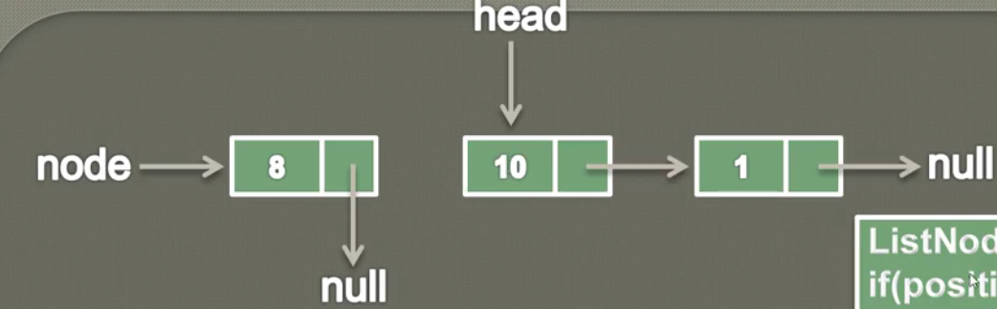

1. Now in if condition, we are checking if position is 1 then insert this node at the position of head and that is why in inside if we are pointing newNode next to head and assigning the newNode value to head.

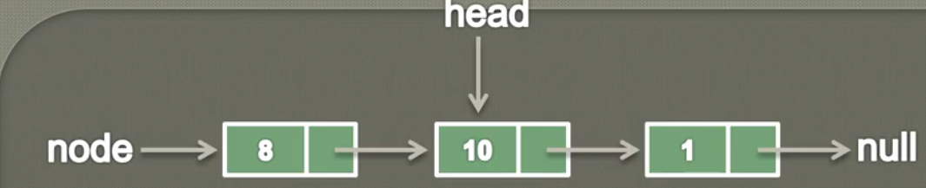

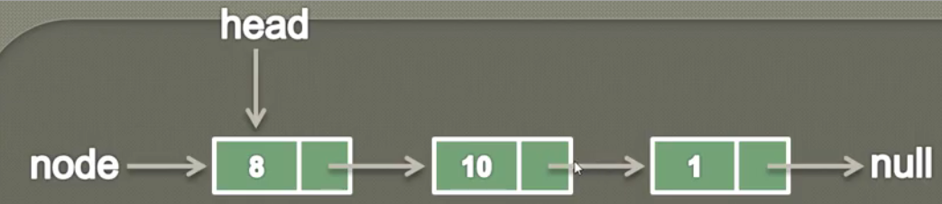

Now the newNode will be treated as head and will be at position 1. And now we will have three nodes.

1. Now let’s say we have value 7 at position 3 like – insert(7,3) so in this case 7 will be inserted ate the place of 1 and the node having value 1 will be shifted to one position ahead.

So first of all we create an independent newNode with the value 7 whose next will point to null. As per the below screen.

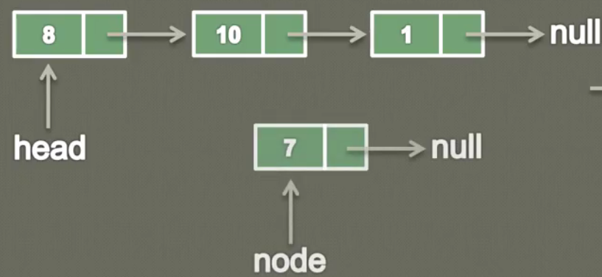

So now first of all curser will go in if condition and will check if position is 1 or not so if condition will comes out to false and then curser will go inside else block.

Inside Else Block:

So the idea to insert at position 3 is that we will traverse till position 2 and break the link and instead of pointing to node 1 we will make it pointing to new node 7 and node 7 will point to node 1. So in this way our new node will be inserted at position 3.

1. First create one ListNode with name previous and assign head to this previous so this previous node will start pointing to node head (I mean first node of the SLL) and in order to keep track we will create one coun

ListNode previous = head;

Int count =1;

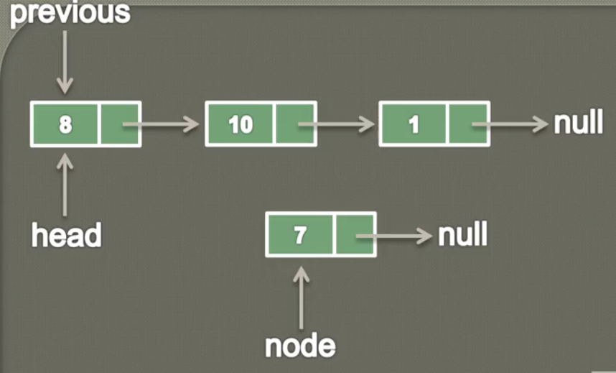

1. Now inside while we will check condition while (cont < position-1) . So now count =1 and position = 3. Condition (1< 3-1) will be true and curser will come inside while loop. Inside while loop we traverse previous (which is currently pointing to head) to previous.next. So now previous node will start pointing to its next node that node 10.

While (count < position-1) {

Previous = previous.next;

Count++

}

Now the previous node is at position 2 (which less than one position where the new node needs to insert) and pointing to node 1.So now to insert 7 between 10 and 1 will break this link. So we follow the below steps.

1. Create one ListNode current and assign previous.next to this current node. In this way a new chain gets created where previous.next i.e. node 1 start pointing to current node.

ListNode current = previous.next;

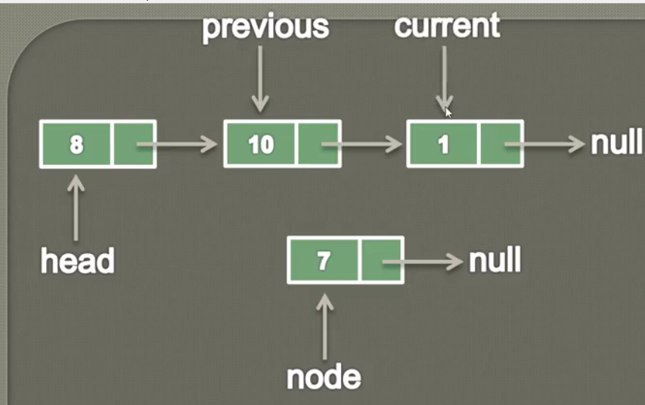

1. Now let’s link this current node (pointing to node 1) to newly created node using below code .

NewNode .next= current; [so in this way newNode 7 and node 1 got linked to each other.

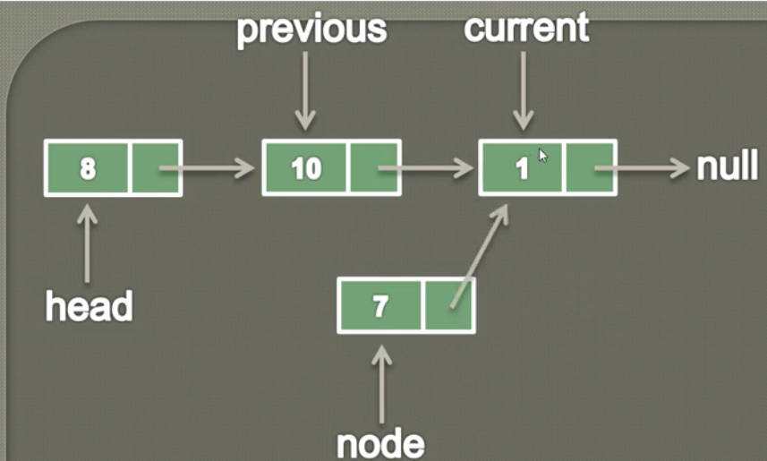

1. Now at the last we will break the link (where previous was pointing to node 1 but now node 1 is hold by current node). So now we will make previous.next (which was pointing to node 1) to point newNode 7

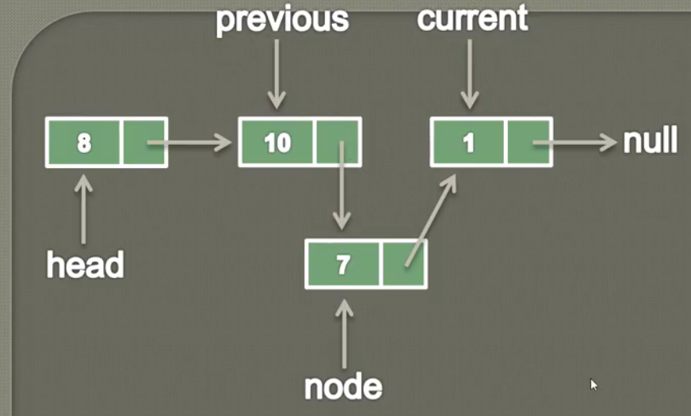 So finally if we stretch the above linked list then it will look like as given below.

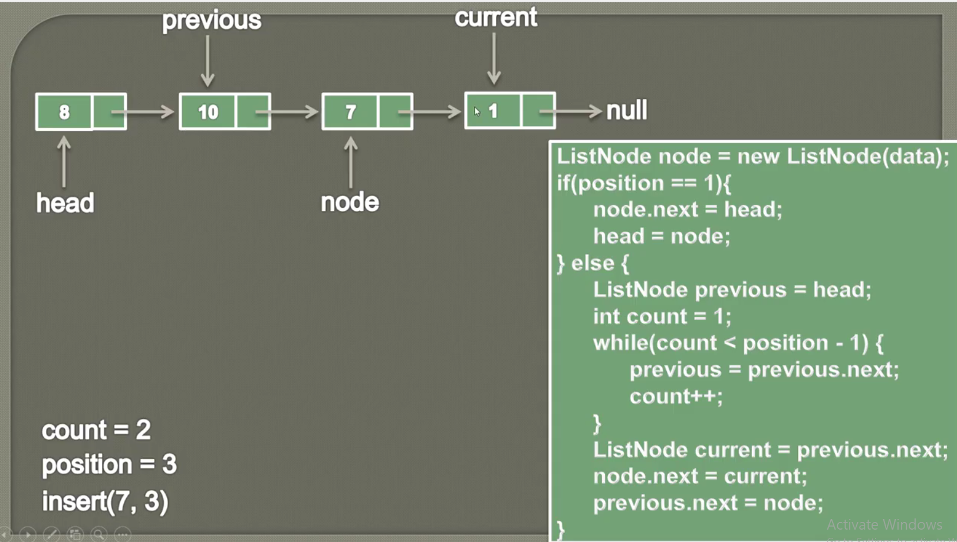

In this way we can add new node in between any of the node:

Note: the above algo is valid for inserting node at the last;

|  |  |
| --- | --- |
|  |  |
|  |  |

And finally as given below

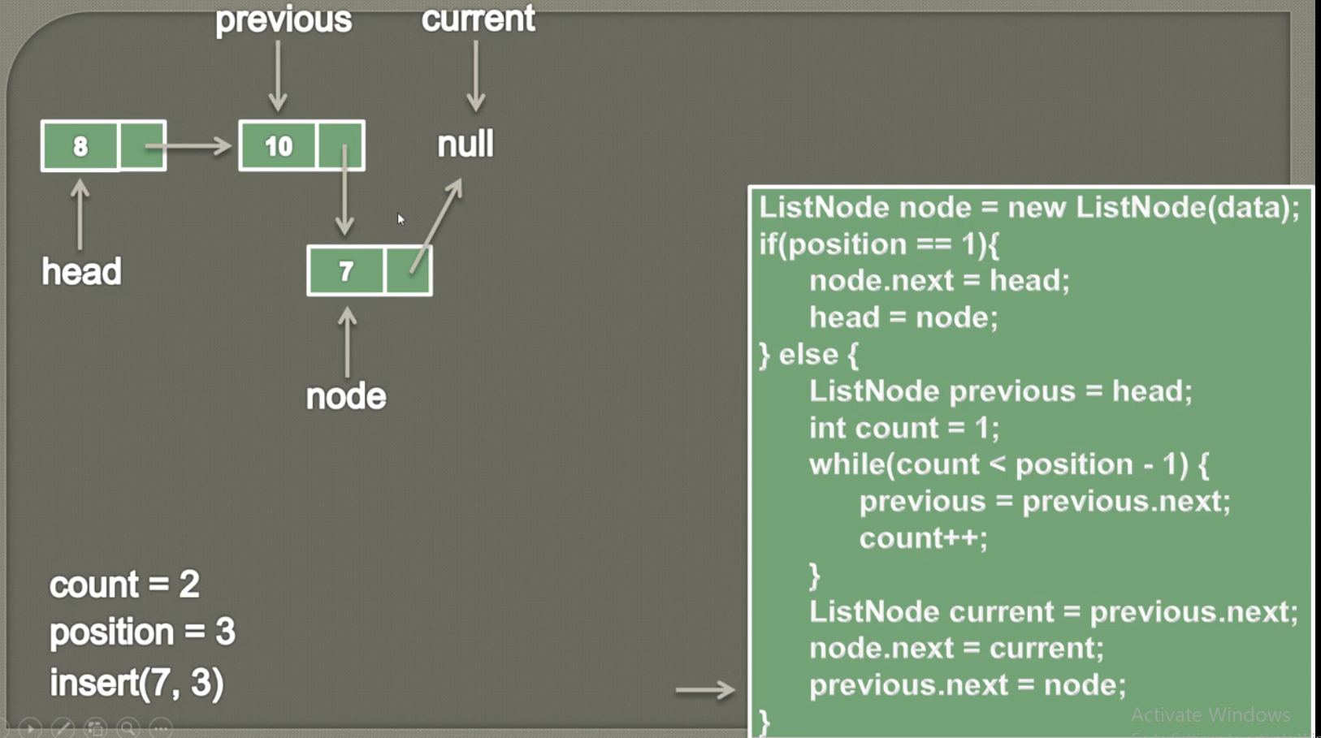

Here we are trying to insert 7 at position 3 which is nothing but the last position of the list because here in the beginning we would have two nodes only.

Program:

|  |
| --- |
| **public** **class** G_InsertNodeAtGivenPosition_7 {  **private** ListNode head;  **public** **static** **class** ListNode{  **private** **int** data;  **private** ListNode next;    **public** ListNode(**int** data) {  **this**.data=data;  **this**.next=**null**;  }  }  **public** **static** **void** main(String[] args) {  System.***out***.println("In the main--");  G_InsertNodeAtGivenPosition_7 sll= **new** G_InsertNodeAtGivenPosition_7();  sll.insertAtPosition(8, 1);  sll.insertAtPosition(9, 1);  sll.insertAtPosition(7, 3);  sll.display();  }  **public** **void** insertAtPosition(**int** value, **int** position) {  ListNode newNode = **new** ListNode(value);  **if**(position==1) {  newNode.next=head;  head=newNode;  }  **else** {  ListNode previous = head;  **int** count=1;  **while**(count < position-1) {  previous = previous.next;  count++;  }  ListNode current = previous.next;  newNode.next=current;  previous.next= newNode;  }  }  **public** **void** display() {  ListNode current = head;  **int** count=0;  **while**(current != **null**) {  System.***out***.print(current.data+"=>");  current = current.next;  count++;  }  System.***out***.print("null");  System.***out***.println();  System.***out***.println("Length of the SLL- "+count);  }  } |
| **Output:**  In the main--  9=>8=>7=>null  Length of the SLL- 3 |

So this is the general algo for inserting at first, in-between and last position in the SLL.

**28-Delete first node of a Singly Linked List in Java (Animation)**

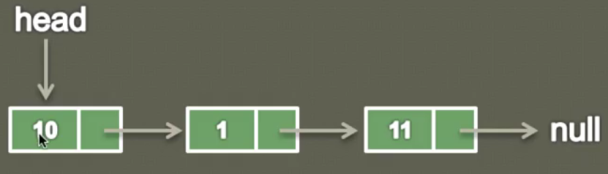

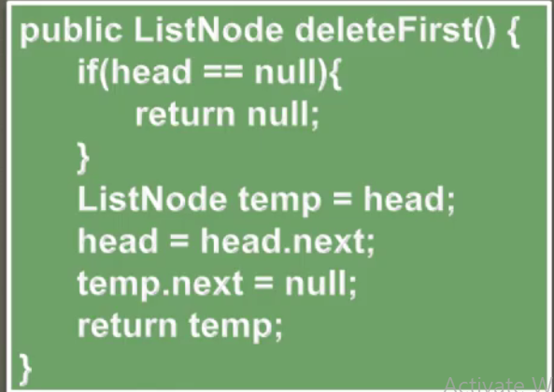

Let’s say we have given a SLL having three nodes. So delete the first node we will use the above algo.

1. If head is null means head does not have any value then return null.
2. Now let’s say head is not null and it holds a series of SLL nodes.
3. So first of all we will create a temp node and assign head to this temp node.

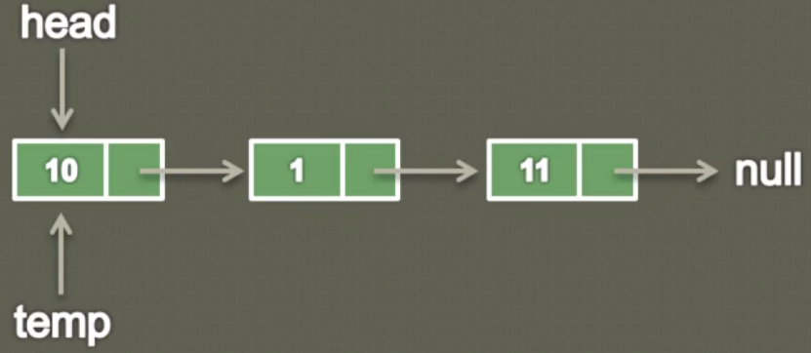

1. Now we have to break the temp link pointing to head. So for this we will shift head to next node i.e. assign the head.next to head. [ head = head.next;] Now the head will start pointing head next node i.e. node 1

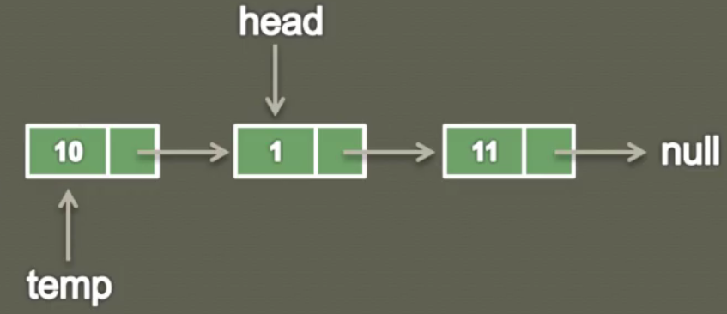

1. But still temp.next is pointing to node 1 which is now becomes the head of SLL. So now let’s assign null to the temp.next = null;

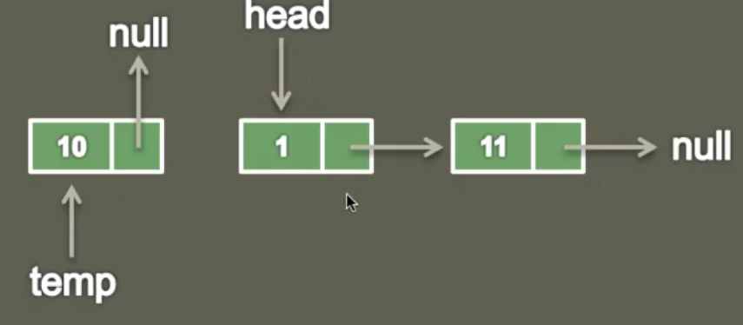

1. And finally return this node temp [ return node;]

|  |
| --- |
| **public** **class** G_InsertNodeAtGivenPosition_7 {  **private** ListNode head;  **public** **static** **class** ListNode{  **private** **int** data;  **private** ListNode next;  **public** ListNode(**int** data) {  **this**.data=data;  **this**.next=**null**;  }  }  **public** **static** **void** main(String[] args) {  System.***out***.println("In the main--");  G_InsertNodeAtGivenPosition_7 sll= **new** G_InsertNodeAtGivenPosition_7();  sll.insertAtPosition(8, 1);  sll.insertAtPosition(9, 1);  sll.insertAtPosition(7, 3);    sll.display();  sll.deleteFirst();  sll.display();  }  **public** **void** insertAtPosition(**int** value, **int** position) {  ListNode newNode = **new** ListNode(value);  **if**(position==1) {  newNode.next=head;  head=newNode;  }  **else** {  ListNode previous = head;  **int** count=1;  **while**(count < position-1) {  previous = previous.next;  count++;  }  ListNode current = previous.next;  newNode.next=current;  previous.next= newNode;  }  }  **public** **void** display() {  ListNode current = head;  **int** count=0;  **while**(current != **null**) {  System.***out***.print(current.data+"=>");  current = current.next;  count++;  }  System.***out***.print("null");  System.***out***.println();  System.***out***.println("Length of the SLL- "+count);  }  **public** ListNode **deleteFirst() { // or public Object deleteFirst() {**  **if(head==null) {**  **return null;**  **}**  **ListNode temp = head;**  **head=head.next;**  **temp.next=null;**  **System.*out*.println("First Deleted Node is:"+temp.data);**  **return temp;**  **}** } |
| **Output:**  In the main--  9=>8=>7=>null  Length of the SLL- 3  First Deleted Node is:9  8=>7=>null  Length of the SLL- 2 |

Note: if we keep calling **deleteFirst ()** then finally we will get the below output.

In the main--

9=>8=>7=>null

Length of the SLL- 3

First Deleted Node is: 9

8=>7=>null

Length of the SLL- 2

First Deleted Node is: 8

7=>null

Length of the SLL- 1

First Deleted Node is: 7

null

Length of the SLL- 0

**30-Delete last node of a Singly Linked List in Java (Animation)**

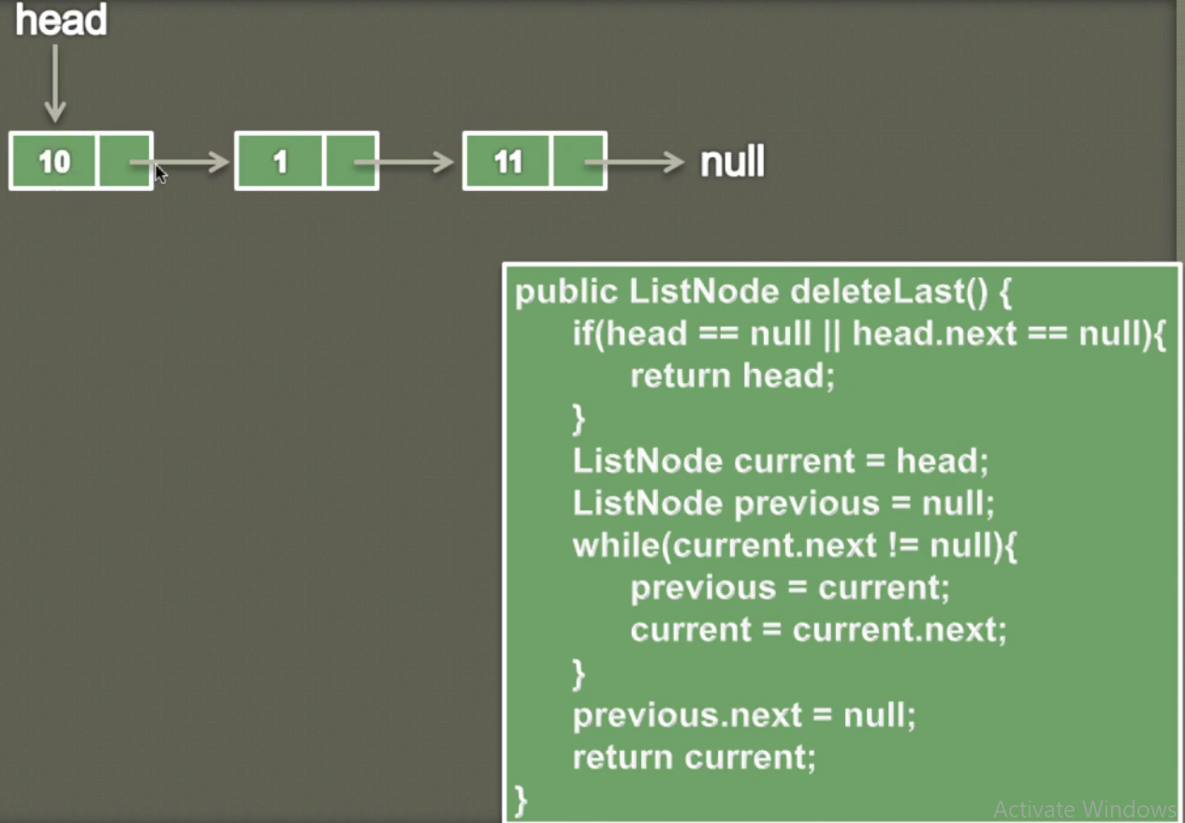

Let’s say we have SLL where head is pointing to node 10. Let’s use the above algo to delete the last node of SLL.

As here we can see that head is pointing to 10 and head next is pointing to 1 and node1 next pointing to 11 and node 11 next is pointing to null. So the idea behind this algo is that we need to traverse somehow to second last node (node 1) and remove the pointing link of node 1 so that last node i.e. node 11 will be unreferenced and will be deleted.

In order to achieve this we will create two new nodes. The one is with name of current which will traverse till last node unit it start pointing to null and another node with the name with previous to second last node so that in order to delete the last node we have break the link from the previous.

So let’s go line by line of the above algo.

1. In the if condition we are checking if(head==null) || (head.next==null) then simply return the head because we don’t have to delete anything. Since here in the SLL head or head.next is not equal to null then curser will not go inside if condition.
2. Now let’s create current node to traverse till last node and create another node previous to traverse till second last node

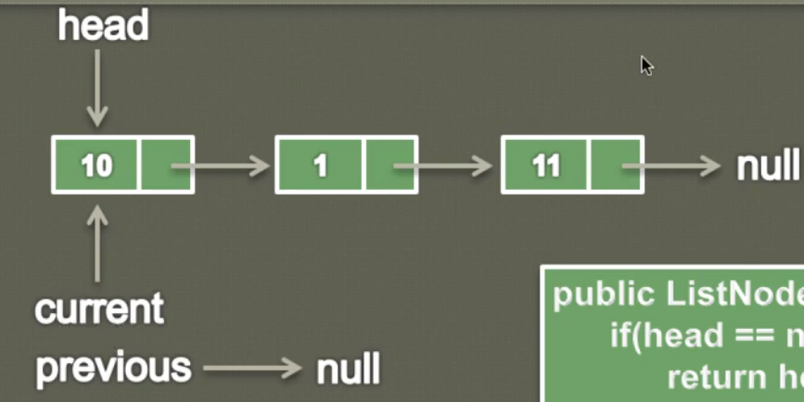

1. Now in the while loop we traverse until current gets null and inside the while loop before moving current to next node we are assigning the current position to previous so that as soon as current traverse forward the its last position will be assigned to previous i.e. previous will be one position back to current node. So before moving current ahead previous will look like as given below.

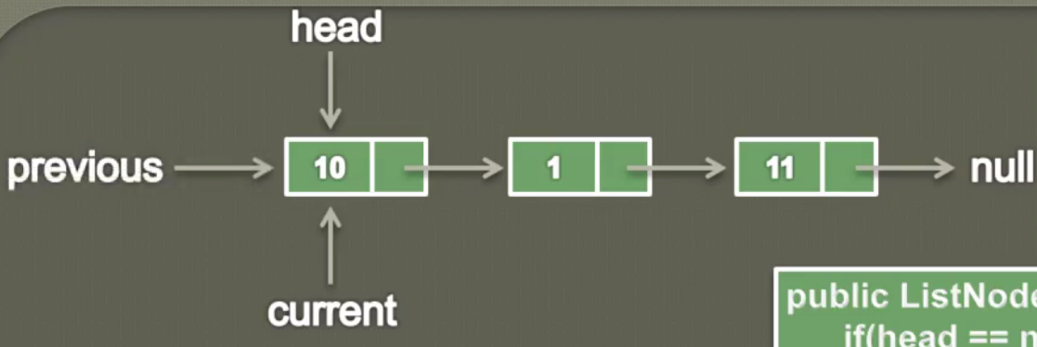

Now move the current to its next node using [current =current.next]. So now the current will start pointing to node 1

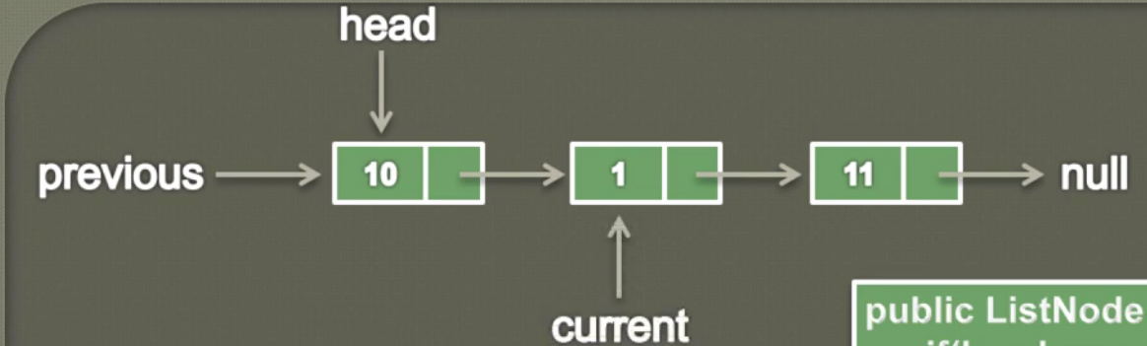

So here we can see the previous is just one node behind of current node.

So we keep traversing using while loop till current reaches last node and previous reaches to second last node.

|  |  |
| --- | --- |
|  |  |

1. As we know to hold the last node we need reference of the second last node. So the idea is to get the reference of second last node so that we can break the linkage just by using [previous.next =null] so now previous.next will start pointing to null instead of pointing to node 11 and thus node 11 will become unreferenced to be garbage collected.

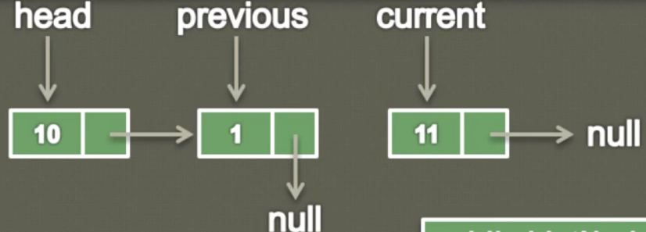

1. Finally we return the current node because current node holds the last node.

And finally we will get SLL like as;

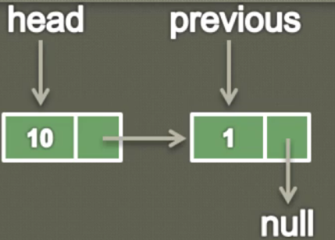

Similarly we can follow the same steps for node 1 to be deleted.

Program:

|  |
| --- |
| **public** **class** I_DeleteLastNode_9 {  **private** ListNode head;  **public** **static** **class** ListNode{  **private** **int** data;  **private** ListNode next;    **public** ListNode(**int** data) {  **this**.data=data;  **this**.next=**null**;  }  }  **public** **static** **void** main(String[] args) {    I_DeleteLastNode_9 sll= **new** I_DeleteLastNode_9();  sll.insertAtPosition(8, 1);  sll.insertAtPosition(9, 1);  sll.insertAtPosition(7, 3);  System.***out***.println("Before Deleting first node-");  sll.display();    sll.deletLast();  sll.display();    }  **public** **void** insertAtPosition(**int** value, **int** position) {  ListNode newNode = **new** ListNode(value);  **if**(position==1) {  newNode.next=head;  head=newNode;  }  **else** {  ListNode previous = head;  **int** count=1;  **while**(count < position-1) {  previous = previous.next;  count++;  }  ListNode current = previous.next;  newNode.next=current;  previous.next= newNode;  }  }  **public** **void** display() {  ListNode current = head;  **int** count=0;  **while**(current != **null**) {  System.***out***.print(current.data+"=>");  current = current.next;  count++;  }  System.***out***.print("null");  System.***out***.println();  System.***out***.println("Length of the SLL- "+count);  }  **public** ListNode deletLast() {  **if**((head==**null**) || (head.next==**null**)) {  **return** head;  }  ListNode current = head;  ListNode previous = **null**;  **while**(current.next != **null**) {  previous=current;  current=current.next;  }  previous.next=**null**;  System.***out***.println("Last Deleted Node is:"+current.data);  **return** current;  }  } |

Output:

Before deleting first node-

9=>8=>7=>null

Length of the SLL- 3

Last Deleted Node is: 7

9=>8=>null

Length of the SLL- 2

**32-Delete a node from a Singly Linked List at a given position (Animation)**

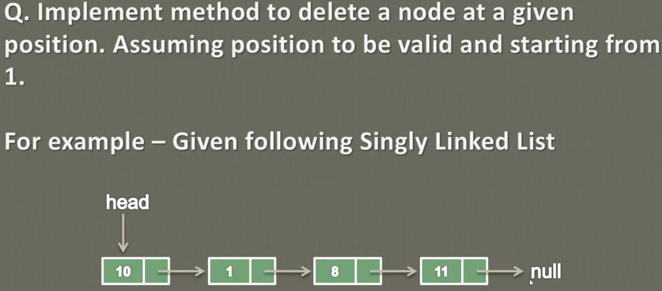

As above we can see that we have one SLL with four nodes. So here could have three positions from where we can delete the node of the SLL.

1. First position i.e. the head of SLL.
2. Last position
3. And in between any two nodes

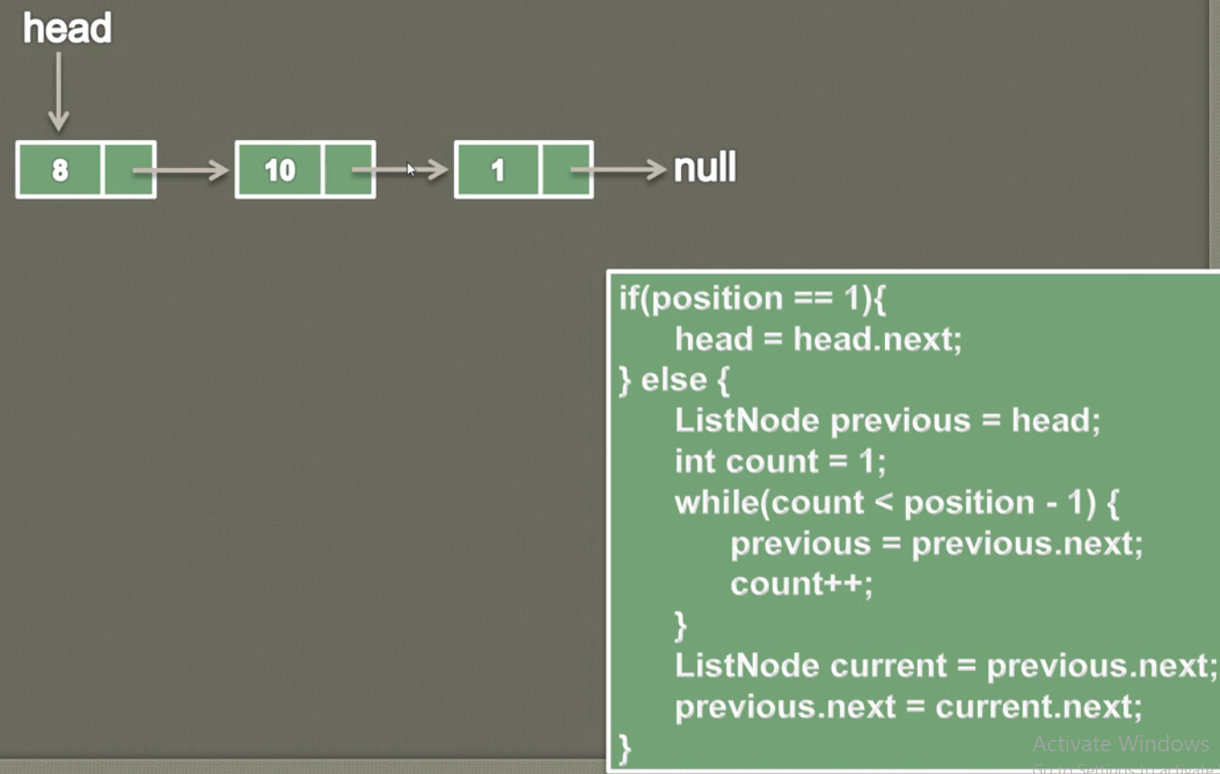

Let’s say we have one SLL with three nodes and now let’s use the given algo to delete the node from a given position.

Case-1: Delete the node of position 1

1. In this case first curser will go inside if condition and move the head to the next node, in this way the first node will become un-referenced and will be available of GC. [head = head.next;] this line will shift head to the second node and second node then will become the first node.

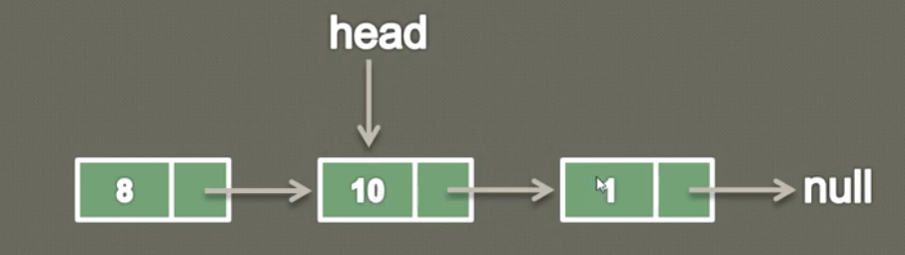

**Case-2:** Delete the node from a given position:

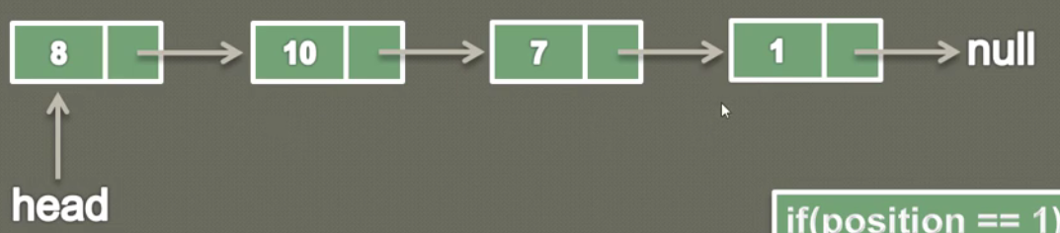 Let’s say we have to delete node 7 i.e. from position 3: Now let’s iterate the above algo:

1. Cursor will come into else block: Now the idea to delete position 3 node is that we have to traverse till second position (one position less form the given position). And to traverse till second position we will create a ListNode previous.
2. To track the previous position we will create one variable count =1.
3. Now in the while loop we will check the condition until count become just one position less than the given position. And inside the while loop in each iteration we will keep moving previous node from position first to till just 1 position away and will keep increasing count variable.
4. Now once the cursor will come out from while loop then previous will contain just 1 position away from the given position from where we have to delete the node. So in this case previous.next will point to deleting position node. So we will break this link and store this link in one temporary variable current.

ListNode current = previous.next;

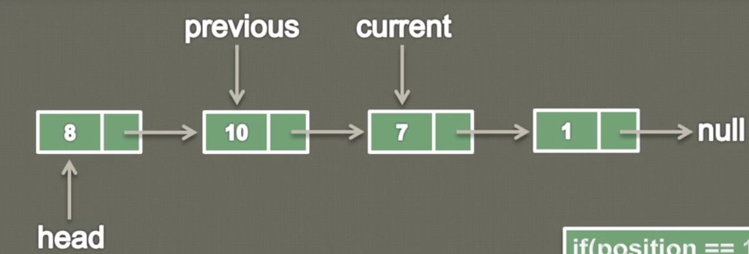

5- Now we will have to point previous.next to the node present after the node to be deleted node. And in this way the previous.next will start pointing to the node present just after to be deleted node. And hence the to be deleted node will become un-referenced and will be available for GC

previous.next = current.next [ Note: Here current.next is pointing to node 1]

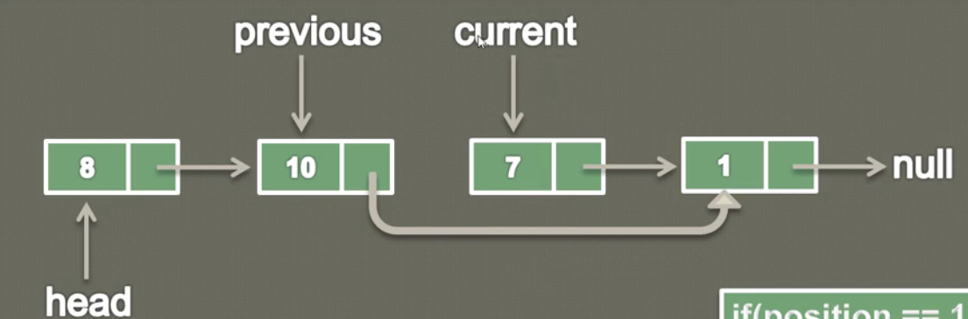

So in this way we can delete the node from a given position.

Program:

|  |
| --- |
| **public** **class** J_DeleteNodeFromGivenPosition_10 {  **private** ListNode head;    **public** **static** **class** ListNode{  **private** **int** data;  **private** ListNode next;    **public** ListNode(**int** data) {    **this**.data=data;  **this**.next=**null**;  }  }  **public** **static** **void** main(String[] args) {  System.***out***.println("Inside main----");    J_DeleteNodeFromGivenPosition_10 sll =**new** J_DeleteNodeFromGivenPosition_10();  sll.insertAtPosition(1, 1);  sll.insertAtPosition(2, 2);  sll.insertAtPosition(3, 3);  sll.insertAtPosition(4, 4);  System.***out***.println("Before Deleting::");  sll.display();  sll.deleate(4);  System.***out***.println("After Deleting::");  sll.display();  }  // insertAtPosition  **public** **void** insertAtPosition(**int** value, **int** position) {  ListNode newNode = **new** ListNode(value);  **if** (position == 1) {  newNode.next = head;  head = newNode;  } **else** { // 1-->9-->5--4  // Create a Node previous which will traverse till one position less than the  // given position where node needs to be added  ListNode previous = head; // Assign head becasue it has to traverse from the head  **int** count = 1; // Created count just to identify the one position less than the exact position  // for newNode considering head at position =1  **while** (count < position - 1) {  previous = previous.next; // Keep moving previous towards forward till count is less than position -1  count++;  }  // Here 8 has to come between 2 & 5 so we have break link at position 2 i.e. at  // node 9.  // let's say previous node is at position 2 i.e. at node 9 then previous.next would point to node5 so we will break the link from here using below line  ListNode current = previous.next; // Holding the previous.next means node 5 and node 4 is now getting linked with current node  previous.next = newNode; // Here now previous.next now start pointing to newNode 8  newNode.next = current; // And finally newNode is start pointing to broken link current having node 5 and 4  }  }  // Display  **public** **void** display() {  ListNode current = head;  **int** count = 0;  **while** (current != **null**) {  System.***out***.print(current.data + "-->");  current = current.next;  count++;  }  System.***out***.print("null");  // \u000d System.***out***.println();  System.***out***.println("Total node =" + count);  }  // Delete node from given position  **public** **void** deleate(**int** position) {    **if**(position==1) {  // shift head to its next node so that first node link could be broken and available for GC  head=head.next;// Head now shifted to its next available node  }// Now if position is in between of the two node  **else** {  /*  * We have to traverse till one position less than the given position. Let's  * create one node previous and assign head // So that we could start traversing  * from beginning of the SLL. And to count previous node postion we will create one count variable.  */  ListNode previous = head;  **int** count =1;  **while**(count < position -1) {  previous = previous.next;  count++;  }  ListNode current = previous.next;  System.***out***.println("Deleated Node is::"+current.data);  previous.next=current.next;  }  }  } |
| **Output:**  Inside main----  Before Deleting::  1-->2-->3-->4-->null  Total node =4  Deleted Node is::4  After Deleting::  1-->2-->3-->null  Total node =3 |

**34-How to search an element in a Singly Linked List in Java**

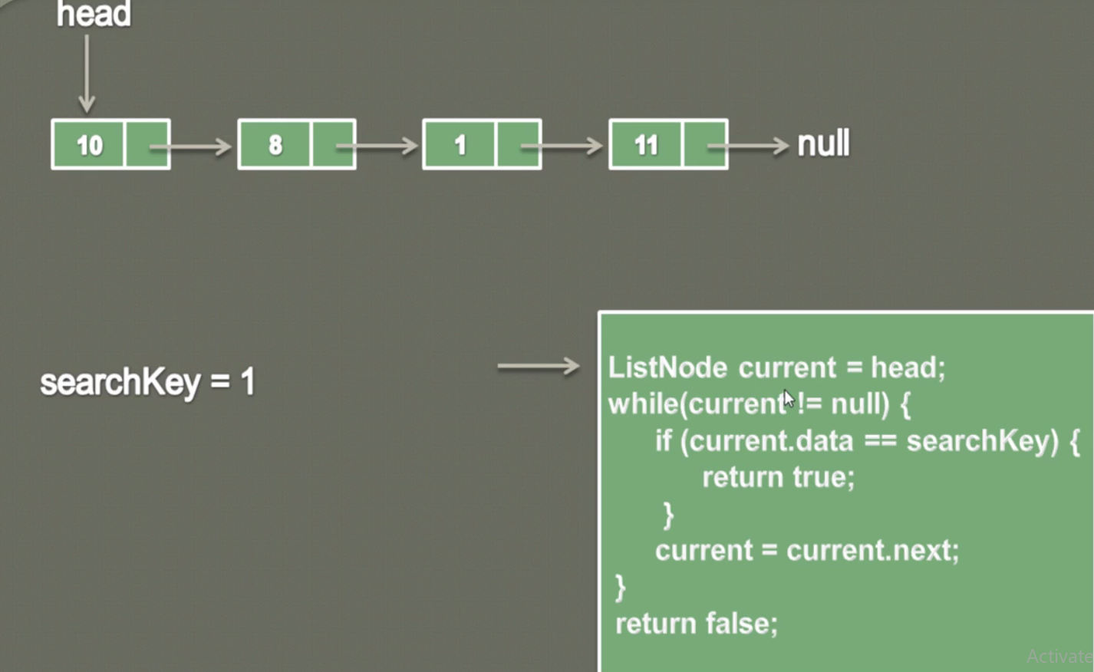

Let’s say we have given a SLL with four nodes. Let’s say we have to search one node have data 1. So let’s talk line by line the given algo to find the search key.

So the idea is that, we will traverse SLL one by one using while loop and inside while loop for each data we are comparing the search key in the if condition.

1. Let’s create one ListNode current and assign head to this current node so that this current node could be traversed from the head (i.e. from the first node).
2. Now in the while put one condition **while** (current! =**null**) then keep moving current to its next node and now in if condition check whether the searchKey is equal to current.data or not.
3. If search key is equal to current.data then return true else keep shifting current to its next.
4. Finally if search key is not found equal to current.data then return false.

|  |  |
| --- | --- |
| **public** ListNode search(**int** value) {  ListNode current = head;  **while**(current !=**null**) {  **if**(current.data==value) {  **return** current;  }  current=current.next;  }  **return** current;  } | **public** boolean search(**int** value) {  ListNode current = head;  **while**(current !=**null**) {  **if**(current.data==value) {  **return** true;  }  current=current.next;  }  **return** false;  } |

**35-Reverse a Singly Linked List in Java _ Data Structures & Algorithms**

ListNode current = head;

ListNode previous = null;

ListNode next = null;

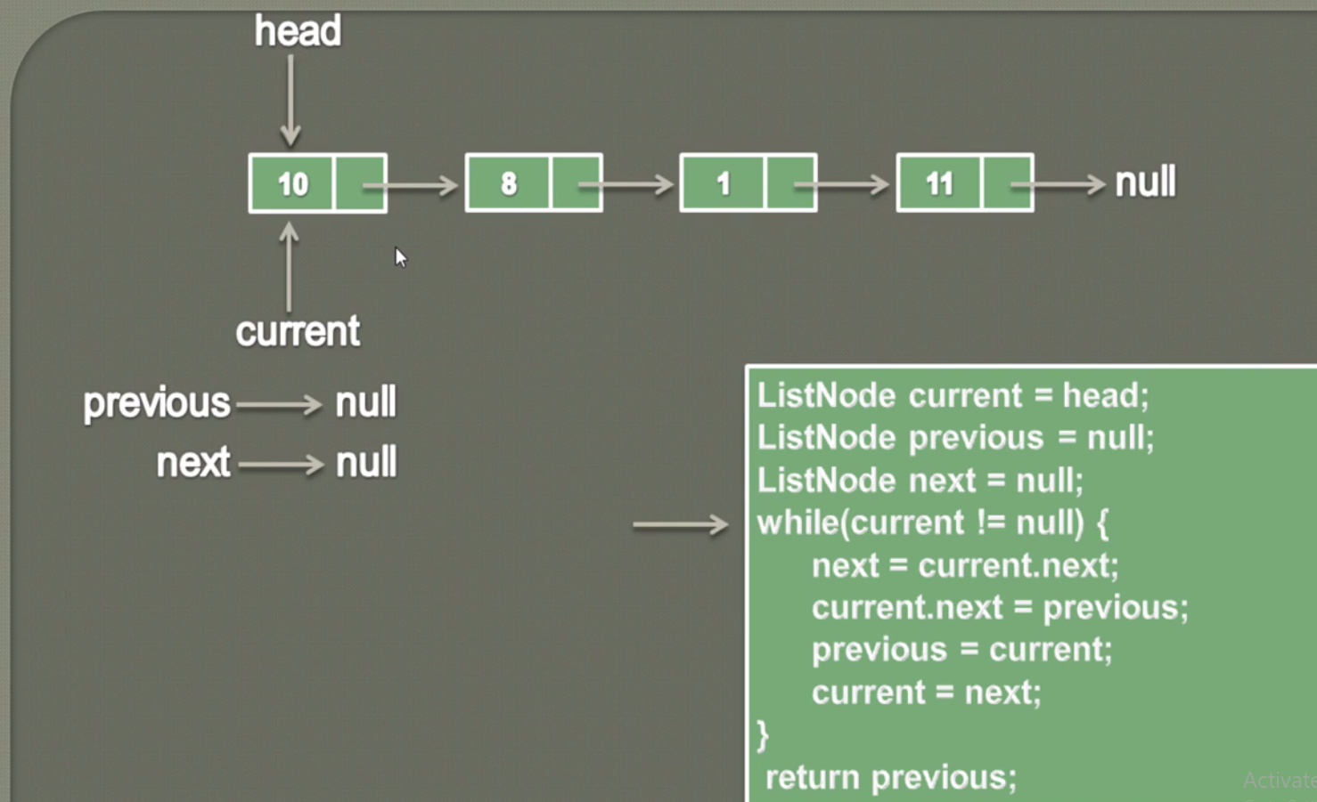

**Inside while loop:** next= current.next

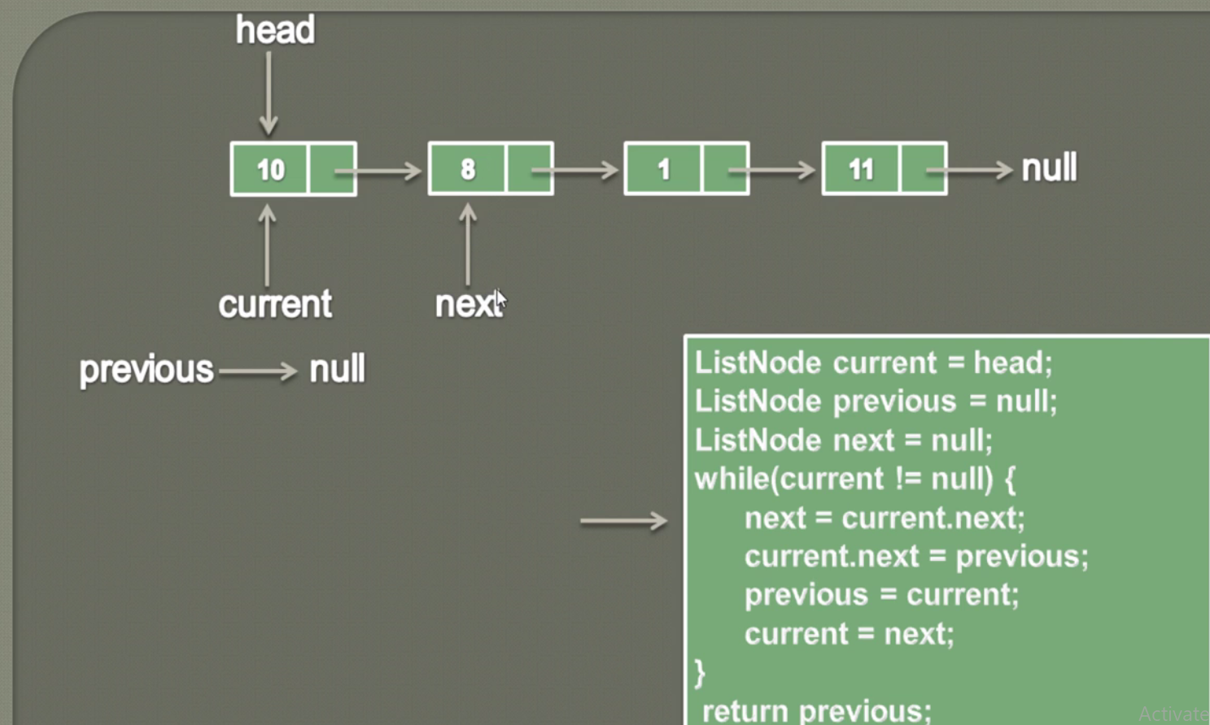

**Current.next = previous;**

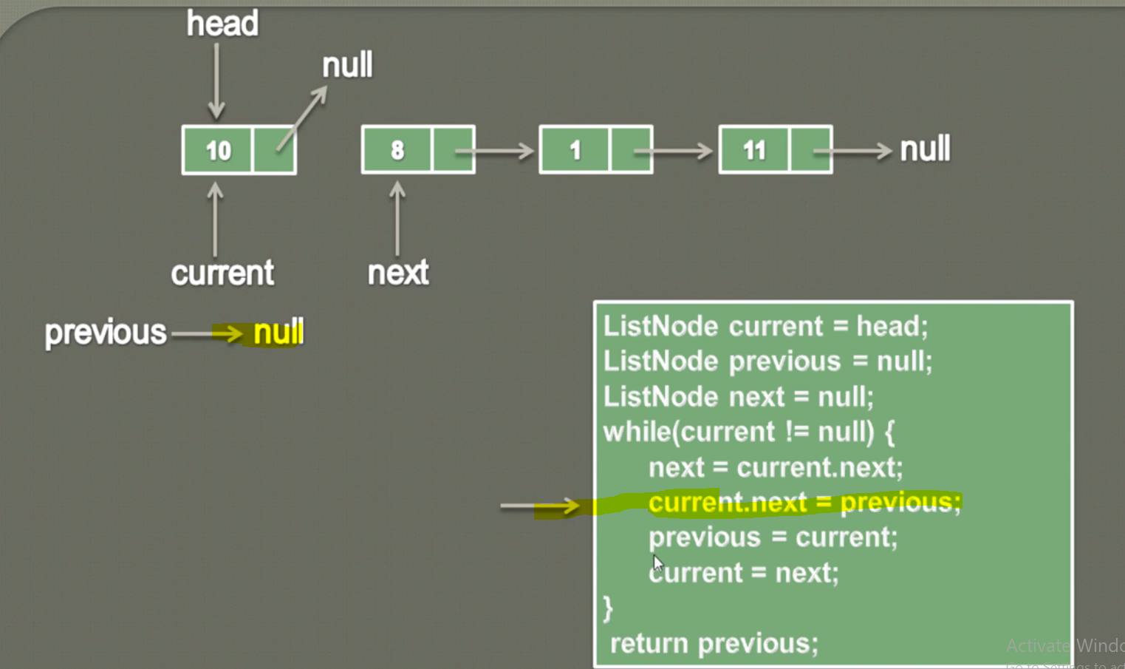

Previous = current [and current is holding first node so now previous node will start pointing to current node]

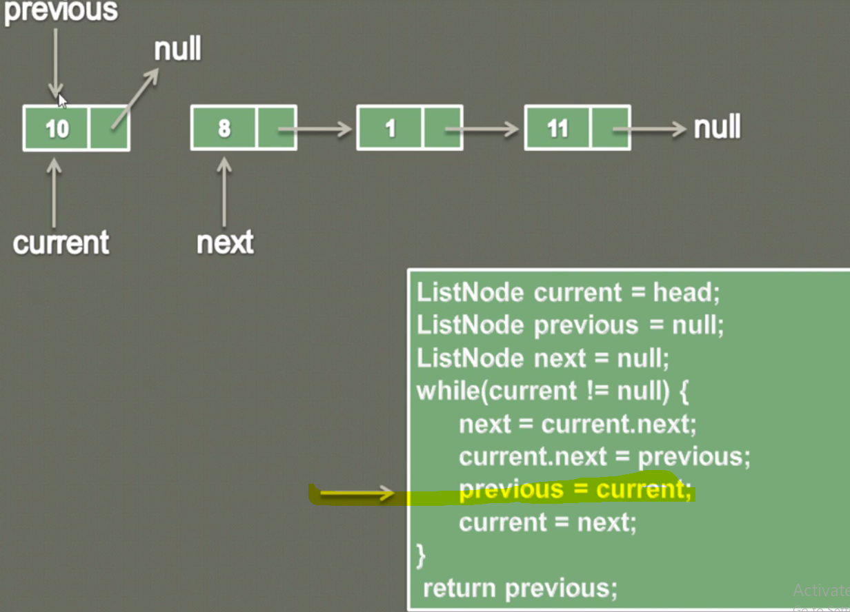

Current = next:

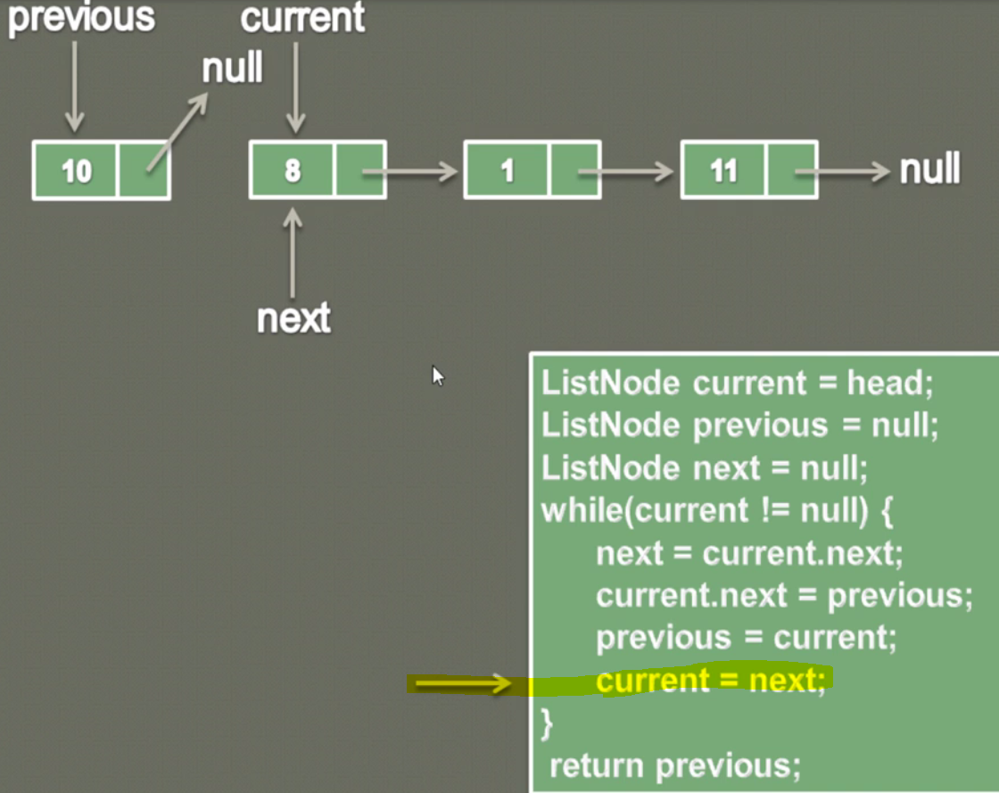

If we re –arrange the above screen shot then it will look like below.

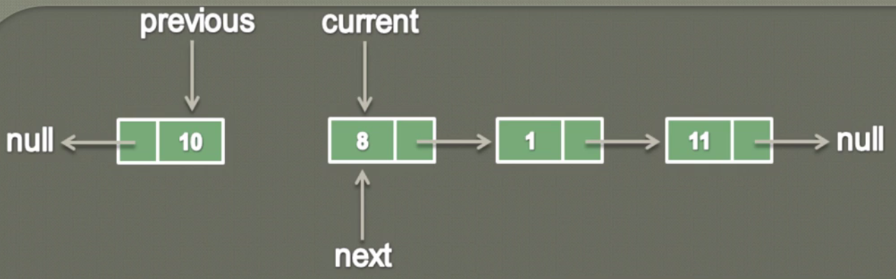

**Now again iterate the while loop**

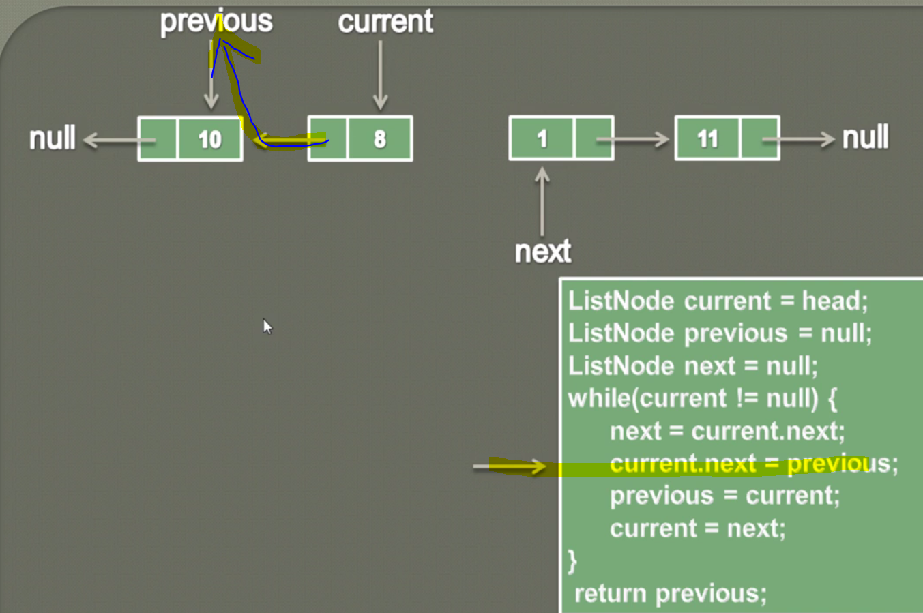

**Previous =current**

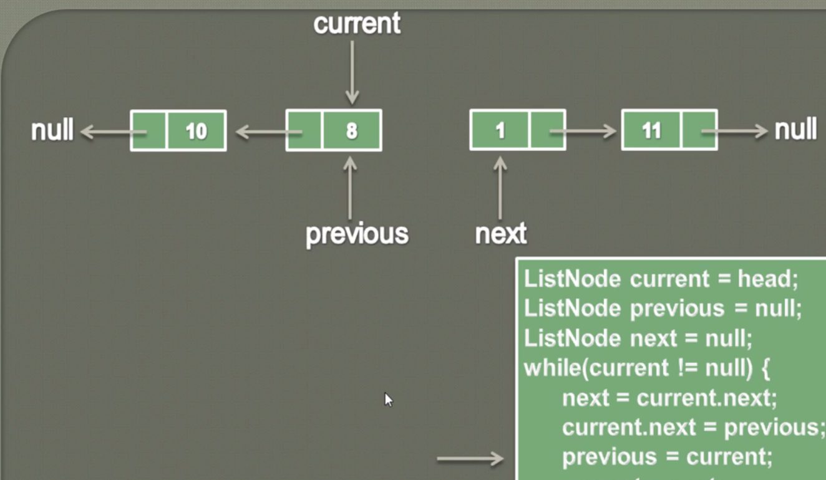

Current=next;

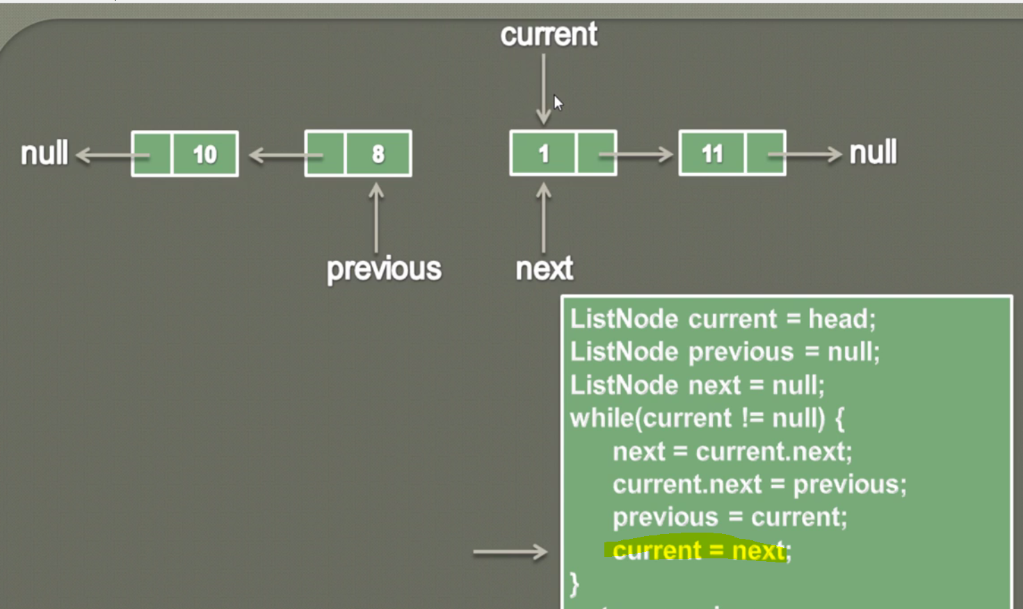

|  |
| --- |
| **public** **void** display(ListNode head) {  ListNode current = head;  **while**(current!=**null**) {  System.***out***.print(current.data+"=>");  current = current.next;  }  System.***out***.print("null");  }  **public** ListNode reverse(ListNode head) {  **if**(head==**null**) {  **return** head;  }  ListNode current = head;  ListNode previous = **null**;  ListNode next = **null**;  **while**(current!=**null**) {  next = current.next;  current.next=previous;  previous=current;  current=next;  }  **return** previous;  } |

Complete Program: